|  |  |  |  |  |  |  |
| --- | --- | --- | --- | --- | --- | --- |
| |  |  |  |  | | --- | --- | --- | --- | |  | | **MINISTRY OF EDUCATION AND TRAINING** | | | **FPT UNIVERSITY** | | |
| Capstone Project Document |
| Online Medical Consultant System |
| |  |  |  |  |  |  |  |  |  |  |  | | --- | --- | --- | --- | --- | --- | --- | --- | --- | --- | --- | | |  |  | | --- | --- | | **Group 02 – Report 1** | | | **Group member** | Trần Nguyên Tiến Sứ - Team Member - SE60781  Trần Cao Danh - Team Member - SE60705 | | **Supervisor** | Mr. Nguyễn Huy Hùng | | **Ext. Supervisor** | N/A | | **Capstone Project code** | OMCS | | |
| – Ho Chi Minh City, 11 May / 2014 – |

*This page is intentionally left blank*

***ACKNOWLEDGEMENTS***

Thank you

# Table of Contents

Table of Contents 4

List of Tables 6

List of Figures 7

Definitions, Acronyms, and Abbreviations 8

Part A. Introduction 9

1. Project Information 9

2. Introduction 9

Part B. Project Management Plan 10

1. Problem Definition 10

1.1. Name of this Capstone Project 10

1.2. Problem Abstract 10

1.3. Project Overview 10

2. Project organization 12

2.1. System Process Model 12

2.2. Roles and Responsibilities 14

2.3. Tools and Techniques 14

3. Project management plan 15

3.1. Product Backlog 15

3.2. Sprint Backlog 23

3.3. All Meeting Minutes 23

4. Convention Rules 23

Part C. System Requirements Specifications (SRS) 24

1. User Requirement Specification 24

1.1. Guest Requirement 24

1.2. User Requirement 24

1.3. Patient Requirement 24

1.4. Doctor Requirement 24

1.5. Admin Requirement 25

2. System Requirement Specification 25

2.1. Use Case Overview 26

2.2. Functional Requirements 30

3. Entity Relationship Diagram (ERD) 65

Data Dictionary 66

Part D. Software Design Description (SDD) 67

1. Design Overview 67

2. System Architectural Design 68

3. Component Diagram 69

4. Detailed Description of Components 69

4.1. Class Diagram 70

4.2. Class Diagram Explanation 71

5. Sequence Diagram 76

5.1. <Guest> Login 76

5.2. <Guest> Register 77

5.3. <Authorized User> Change Password 78

5.4. <Authorized User> Change Profile Picture 78

5.5. <Patient> Conversation 79

5.6. <Doctor> Request Webcam 80

5.7. <Patient> Upload Attachment 80

5.8. <Admin> Define New Medical Profile Template 81

5.9. <Admin> Update Medical Profile Template 82

5.10. <Doctor> Update Medical Profile 83

5.11. <Doctor> Views Medical Profile 84

5.12. <Patient> Update Personal Health Record 84

5.13. <Patient> View Medical Profile 85

6. User Interface Design 85

7. Database Design 86

# List of Tables

Table 1: Hardware Requirement for Server 13

Table 2: Hardware Requirement for Web User 13

Table 3 Roles and Responsibilities 15

Table 4 Product Backlog 23

Table 5 <Guest> Login 33

Table 6 <Guest> Register 34

Table 7 <Doctor><Admin> View Medical Profile 35

Table 8 <Doctor><Patient> Chat 36

Table 9 <Doctor> Request Webcam 37

Table 10 < Patient> Show webcam 39

Table 11 <Doctor>< Patient> Upload Attachment 40

Table 12 < Patient> View consult history 41

Table 13 < Patient> View doctor online 43

Table 14<Doctor>< Admin> Update medical profile 44

Table 15 <Admin> Create doctor 45

Table 16 <Admin> Edit doctor 47

Table 17<Admin> Search doctor 48

Table 18 <Admin> Deactivate Doctor 50

Table 19 <Admin> Activate doctor 51

Table 20 <Admin><Doctor> Create patient 52

Table 21 <Admin><Doctor> Edit patient 54

Table 22 <Admin><Doctor> Search patient 56

Table 23 <Admin> Deactivate patient 57

Table 24 <Admin> Activate patient 58

Table 25 <Admin> Update medical profile template 59

Table 26 <Admin><Doctor><Patient> Change picture profile 61

Table 27 <Admin><Doctor><Patient> Change password 63

Table 28 <Admin> Define new medical profile template 64

Table 29 <Admin><Doctor><Patient> Logout 65

# List of Figures

Figure 1 Scrum framework 14

Figure 2 System Use Case Overview 27

Figure 3 <Guest> Use Case Overview 28

Figure 4 <Authorized User> Use Case Overview 28

Figure 5 <Admin> Use Case Overview 29

Figure 6 <Doctor> Use Case Overview 30

Figure 7 <Patient> Use Case Overview 31

Figure 8 <Guest> Login 31

Figure 9 <Guest> Register 33

Figure 10 <Doctor><Patient> View Medical Profile 34

Figure 11 <Doctor><Patient> Chat 35

Figure 12 <Doctor> Request Webcam 37

Figure 13 < Patient> Show webcam 38

Figure 14 <Doctor>< Patient> Upload Attachment 39

Figure 15< Patient> View consult history 40

Figure 16 < Patient> View doctor online 42

Figure 17 <Doctor>< Admin> Update medical profile 43

Figure 18 <Admin> Create doctor 44

Figure 19<Admin> Edit doctor 46

Figure 20 <Admin> Search doctor 47

Figure 21 <Admin> Deactivate Doctor 49

Figure 22 <Admin> Activate doctor 50

Figure 23 <Admin><Doctor> Create patient 51

Figure 24 <Admin><Doctor> Edit patient 53

Figure 25 <Admin><Doctor> Search patient 54

Figure 26 <Admin> Deactivate patient 56

Figure 27 <Admin> Activate patient 57

Figure 28 <Admin> Update medical profile template 58

Figure 29<Admin><Doctor><Patient> Change picture profile 60

Figure 30 <Admin><Doctor><Patient> Change password 61

Figure 31 <Admin> Define new medical profile template 63

Figure 32 <Admin><Doctor><Patient> Logout 64

Figure 33 Entity Relationship Diagram 66

Figure 34: MVC Architecture 69

Figure 35: Component Diagram 70

Figure 36 Class Diagram 71

Figure 37: <Guest> Login Sequence Diagram 77

Figure 38: <Guest> Register Sequence Diagram 78

Figure 39: <Authorized User> Change Password Sequence Diagram 79

Figure 40: <Authorized User> Change Profile Picture Sequence Diagram 79

Figure 41: <Patient> Conversation Sequence Diagram 80

Figure 42: <Doctor> Request Webcam Sequence Diagram 81

Figure 43: <Patient> Upload Attachment 81

Figure 44 <Admin> Define New Medical Profile Template 82

Figure 45 <Admin> Update Medical Profile Template 83

Figure 46: <Doctor> Update Medical Profile 84

Figure 47: <Doctor> Views Medical Profile 85

Figure 48: <Patient> Update Personal Health Record 85

Figure 49 Database Relationship Design 87

Figure 50 2.1.2. Performance Requirement 89

Figure 51 Scenarios Frequency 90

# Definitions, Acronyms, and Abbreviations

|  |  |
| --- | --- |
| OMCS | Online Medical Consultant System |

# Introduction

## Project Information

* Project name: **Online Medical Consultant System**
* Project Code: **OMCS**
* Product Type: **Web Application**
* Start Date: **May 11th, 2014**
* End Date: **August, 25th, 2014**

## Introduction

With the emergence of the Internet, many systems have been built to reduce the gap between patients and doctors. They provide the convenient way by let patient communicate face-to-face with health care provider via social media. That is successful story from many developed countries that we try to apply for Vietnam using different approaches.

Nowadays, Vietnam hospitals usually are overwhelmed[1] with patients. A lot of plans have been proposed to handle that situation[2]. Besides that, taking a medical treatment at hospitals not always a good choice due to the traveling cost, wasting time and unsafeness[3].

Based on observation, we see that there are many cases that patients don’t need to go to the hospital quite often because those can easily conduct via internet. So we want to improve the processes of medical treatment.

Reference:

[1] http://nld.com.vn/suc-khoe/loay-hoay-chuyen-giam-tai-benh-vien-20120315104111496.htm

[2] http://www.vietnamplus.vn/no-luc-giam-qua-tai-cac-benh-vien-tai-tp-ho-chi-minh/245738.vnp

[3] http://www.nhandan.com.vn/suckhoe/tieu-diem/item/22586202-bat-an-nhu-vao%E2%80%A6-benh-vien.html

[4] http://www.jmir.org/2013/10/e220/

# Project Management Plan

## Problem Definition

### Name of this Capstone Project

The official and formal project name is “Online Medical Consultant System”. Its abbreviation is OMCS.

### Problem Abstract

This system aims to provide the convenient way for doctor and patient to exchange information (chatting, sharing webcam, attachment).

In order to conduct a high quality consulting based on reliable information. This system helps hospitals to build medical profile template.

With many medical profiles linked to one patient, it’s more easier to extract some common information like immunization, allergy.

### Project Overview

#### The Current System

In Vietnam, there are some websites provide medical consultant services:

* **Alobacsi** *“Vì sức khỏe người Việt”*

<http://alobacsi.vn/kham-benh-online.htm>

Users can search questions in knowledge base (nearly 100.000 questions with answers). Make question by submit the form.

* **Tuvansuckhoe24h** *“Chia sẽ cùng chuyên gia”*

<http://www.tuvansuckhoe24h.com.vn/>

Support chatting using yahoo. Ask question for consultants

* **Bacsytructuyen**

<http://bacsytructuyen.com/>

This website collect articles, tips related to medical from many resources. Users can access those information. Besides that, patients can submit question by filling the form

All above systems have many disadvantages:

* Lack of interaction between patients and doctors
* Hardly can provide high quality consulting service due to missing reliable resources (medical profile, allergy, immunization,…)
* Patient cannot able to manage their own profile information, medical heath record

#### The Proposed System

The main system will be a website. It’s intended for used in one hospital or clinic.

The system will provide the following main features:

* *Hospital admin:*
* Define a template for medical profile with high customization, reusable patient information and built-in components.
* Update hospital information.
* Manage doctors, patients, specialty fields, film types, allergy types.
* Manage all created medical profiles.
* Manage comments from patient.
* *Doctors:*
* Manage patient information.
* Use predefined templates to create medical profile for patient.
* View conversation history, chat with patient.
* Request patient to show their webcam.
* View medical profile template.
* *Patients:*
* Manage some basic information, health medical record.
* View their medical profile.
* Request doctor to get consulted, share webcam, upload attachment.

#### Boundaries of the System

* The system is intended for using in one hospital (we named it as FPT Hospital)
* The language of the system is Vietnamese.
* The complete product includes:
* The website, for admin, doctor, patient to interactive with system.
* All the documents, reports during the time develop the system.
* This system currently not included for these features:
* Exporting medical profile.
* Managing medicine.
* Managing process of a hospital.
* This system not intend to replace the current medical treatment processes in hospital. It just provide the convenient and reliable ways to conduct medical consultant online, especially in re-examination.

#### Development Environment

##### Hardware requirements

**For server**

|  |  |  |
| --- | --- | --- |
| Windows | Minimum Requirements | Recommended |
| Internet Connection | 4Mbps | 8 Mbps |
| Operating System | Window Server 2008 | Window Server 2012 |
| Computer Processor | Intel® Core 2 Duo | Intel® Core(TM) i5 CPU , M 460 @ 2.53GHz |
| Computer Memory | 1GB RAM | 3GB or more |

Table : Hardware Requirement for Server

**For Web User**

|  |  |  |
| --- | --- | --- |
| Web | Minimum Requirements | Recommended |
| Internet Connection | 2Mbps | 4Mbps |
| Web Browser | Chrome 22 | Chrome 36 |

Table : Hardware Requirement for Web User

##### Software requirements

* OS: Microsoft Windows 7.
* Skype: used for communication and meeting
* Google Code & TortoiseSVN: used for source control.
* Website Server: IIS 7 Express
* IDE: Visual Studio 2012
* DBMS: SQL Server 2008 R2
* StarUML 5.0

## Project organization

### System Process Model



Figure Scrum framework

We decided to apply SCRUM methodology in our project with many customizations:

* **Roles**

Teacher plays as a Product Owner and Scrum Master

Students play as Development Team

* **Event**

*Sprint*: each sprint is timeboxed for one week. Start and end at the same date

*Meeting*:

* *Planning 1*: choose stories from product backlog and put them into sprint backlog
* *Planning 2*: not conduct due to lack of time and resources
* *Daily meeting*: conduct every evening by using Skype
* *Review meeting*: conduct at the end of sprint where PO review the work that was completed
* *Retrospective meeting*: rarely hold. To take a look back on the previous sprints and discuss to made agreement for improvement
* **Artifacts**

*Product backlog*: list of requirements that are created and managed by PO.

*Sprint backlog*: list of works for the Development Team must address during the sprint.

*Burndown chart*: not conduct

*Impediment*: list of difficulties that the team meet during handle tasks.

* Reference Appendix: Impediment Backlog.

### Roles and Responsibilities

|  |  |  |
| --- | --- | --- |
| Full name | Role in Group | Responsibilities |
| Nguyễn Huy Hùng | Scrum Master, Product Owner | * Ensuring the team deliver value to the business * Manage product backlog, prioritizes userstory * Facility the team |
| Trần Nguyên Tiến Sứ | Team member | * Tracking & managing progress. * Designing database. * Analyzing requirements. * Planning & scheduling. * Coding. * Testing. * Writing documents & reports |
| Trần Cao Danh | Team member | * Analyzing requirements. * Designing database. * Coding. * Testing. * Writing documents. |

Table Roles and Responsibilities

### Tools and Techniques

#### Tools:

* IDE: Microsoft Visual Studio 2012.
* DBMS: Microsoft SQL server 2008 R2 Express: Used as the database of the system.
* SVN: TortoiseSVN.
* Task management: Trello (<https://trello.com/>)
* Web browsers: Google Chrome, Firefox.
* Web Server: Microsoft IIS 7.0

#### Technologies:

* Web framework: ASP.NET MVC 4
* Entity Framework Model First
* Front-end: Backbone.js, Underscore.js, RequireJS, HTML 5, CSS 3, AJAX, Bootstrap

## Project management plan

### Product Backlog

|  |  |  |  |  |  |  |
| --- | --- | --- | --- | --- | --- | --- |
| **No.** | **Category** | **Userstory** | **Description** | **Acceptance criteria** | **Delivery date** | **Sprint** |
| 1 | Document | Report 1 | As a team member, I want to have the introduction about the project so that I can understand the initial idea. | The report should follow the template from FPT University Good layout, cover all items | 20 May, 2014 | 1 |
| 2 |  | Report 2 | As a team member, I want to have the Project Management Plan so that I can work well on the project | The report should follow the template from FPT University Good layout, cover all items | 05 June, 2014 | 2, 3 |
| 3 |  | Report 3 | As a team member, I want to have the System Requirements Specifications | The report should follow the template from FPT University Good layout, cover all items All features are listed out and analysed carefully | 12 June, 2014 | 3, 4 |
| 4 |  | Report 4 | As a team member, I want to have the System Design Specifications so that I can have a good design to follow | The report should follow the template from FPT University Good layout, cover all items | 09 July, 2014 | 4, 5, 6, 7, 8 |
| 5 |  | Report 5 | As a team member, I want to have System Implementation & Test document so that I can have full-featured and well-tested release | The report should follow the template from FPT University Good layout, cover all items | 09 July, 2014 | 9, 10 |
| 6 |  | Report 6 |  | The report should follow the template from FPT University Good layout, cover all items | 05 June, 2014 | 2, 3 |
| 7 |  | Team document | As a team member, I want to have some document  (product backlog, sprint backlog, team wiki) created. So I can work well on OMCS | Product backlog with detail description, acceptance criteria, and delivery date Sprint backlog with breaked tasks with assignee |  | 1 |
| 8 | Feature | [User] Login | As a user, I want to login to the system | Login using email After login, redirect user based on their role |  | 1 |
| 9 |  | [User] Login with remember me | As a user, I want to login automatically |  |  |  |
| 10 |  | [User] Logout | As a user, I want to logout |  |  |  |
| 11 |  | [User] Register | As a guest, I want to register new account | Only required some basic information Send email to confirm email address Use capcha to enhanced security |  | 1 |
| 12 |  | [User] Forget password | As a user, I want to get new password by email when I forgot it, so that I can continue to use OMCS | Send email with gerenated new password |  | 1 |
| 13 |  | [User] Edit profile information | As a user, I want to update some information (firstname, address…) | Validate required fields, number |  | 1 |
| 14 |  | [Patient] View medical profile | As a patient, I want to view my medical profile, so that I can have overview about my dieases | List all medical profiles created for logged in patient Not allow patient to modify medical profile |  |  |
| 15 |  | [Patient] View linked medical profile information | As a patient, I want to extract some information (immunization, allegy) so that I can quickly have overview about them | Only show medical profile that use built-in modules (immunization, allergy) Link to medical profile that have extracted information |  |  |
| 16 |  | [Patient] Update patient information | As a patient, I want to update some information about my profile, basic health record | For user experience, use in-place editor to edit information |  |  |
| 17 |  | [Patient] Chat | As the user, I want to chat with doctor realtime So I can send message and doctor receive immediately | The behavior could be: The system list out all doctors with their status Patient can select doctor to chat with Patient can see old chat content |  |  |
| 18 |  | [Patient] Show webcam | As a patient, I want to share my webcam so the information's exchange is more easier | Doctor can see the stream that patient share Doctor can see the stream in full-screen |  |  |
| 19 |  | [Patient] Upload attachment | As a patient, I want to attach some files, images and send to doctor | If attach files are images, display on the chat content, otherwise, let doctor download it |  |  |
| 20 |  | [Patient] View consult history | As a patient, I want to see previous chat content with doctor, so that I haven't to remember everything | List all chat content with the sent time Sort chat message by time |  |  |
| 21 |  | [Patient] View doctor online | As a patient, I want to see who is online, so that I can get quickly response | When doctor go to Conversation page, their status is shown as online for patient Patient can see status real-time, donot need to refresh the page |  |  |
| 22 |  | [Patient] Change profile picture | As a patient, I want to change my profile picture |  |  |  |
| 23 |  | [Patient] Change password | As a patient, I want to change my password | Patient have to re-enter current password Patient have to enter new password twice |  |  |
| 24 |  | [Patient] Rating doctor | As a patient, I want to rate doctor for his consulting | Maximum point is 5 Doctor and other patients can see the average point of rating |  |  |
| 25 |  | [Patient] Comment doctor | As a patient, I want to give my comment for doctor so that I can show my opinions/ideas | Doctor and other patients can see the comment Doctor can comment to reply |  |  |
| 26 |  | [Doctor] Chat | As a doctor, I want to chat with patients so that I can help them | Doctor can see unread messages |  |  |
| 27 |  | [Doctor] Request webcam | As a doctor, I want to request camera from patients when needed | Only request to one patient at the same time |  |  |
| 28 |  | [Doctor] Upload attachment | As a doctor, I want to upload attachment and send to patient, so useful data could be exchange | If attach files are images, display on the chat content, otherwise, let patient download it |  |  |
| 29 |  | [Doctor] Create medical profile | As a doctor, I want to create medical profile for patient, so that I can update it instantly | Doctor can choose any exsting template to create One patient with have only one medical profile created from one template |  |  |
| 30 |  | [Doctor] View medical profile | As a doctor, I want to view medical profile of a patient, so that I can have overview about his diseases | Doctor can view medical profile created by other doctors |  |  |
| 31 |  | [Doctor] Update medical profile | As a doctor, I want to update medical profile created for patient |  |  |  |
| 32 |  | [Doctor] Create patient | As a doctor, I want to create account for patient so that new patient can use application instanly | Password of patient is sent to patient's email automatically |  |  |
| 33 |  | [Doctor] Edit patient information | As a doctor, I want to edit patient information, so that I can correct information |  |  |  |
| 34 |  | [Doctor] View comment/rating | As a doctor, I want to view comment/rating so that I can know feedback from patients |  |  |  |
| 35 |  | [Doctor] Add comment | As a doctor, I want to add new comment so that I can interact with my patients effectively |  |  |  |
| 36 |  | [Doctor] Search patient | As a doctor, I want to search patient so that I can increase my work performance |  |  |  |
| 37 |  | [Doctor] Change picture profile | As a doctor, I want to change my profile picture |  |  |  |
| 38 |  | [Doctor] Change password | As a doctor, I want to change my password | Doctor have to re-enter current password Doctor have to enter new password twice |  |  |
| 39 |  | [Admin] View medical profile | As an admin, I want to view medical profile from all patients for management |  |  |  |
| 40 |  | [Admin] Create doctor | As an admin, I want to create new doctor for my hospital | Admin can edit some information during add new doctor |  |  |
| 41 |  | [Admin] Edit doctor | As an admin, I want to edit information of a doctor, so that I can correct wrong information |  |  |  |
| 42 |  | [Admin] Search doctor | As an admin, I want to search doctors so that I can increase my work performance |  |  |  |
| 43 |  | [Admin] Deactive/Active doctor | As an admin, I want to deactive/active doctor, so that I can operate system well | Deactive doctor cannot access to the system anymore |  |  |
| 44 |  | [Admin] Create patient | As an admin, I want to create new patient |  |  |  |
| 45 |  | [Admin] Edit patient | As an admin, I want to edit some information of patient |  |  |  |
| 46 |  | [Admin] Search patient | As a admin, I want to search patient so that I can increase my work performance |  |  |  |
| 47 |  | [Admin] Deactive/Active patient | As an admin, I want to deactive/active patient, so that I can operate system well | Deactive patient cannot access to the system anymore |  |  |
| 48 |  | [Admin] Define medical profile template | As an admin, I want to define new medical profile template for my hospital | Template can re-use existing information from patients Template can use some built-in modules of system |  |  |
| 49 |  | [Admin] Update medical profile template | As an admin, I want to update medical profile template, so that my template can stay update with new changes | After updating, a summary changes should be listed out |  |  |
| 50 |  | [Admin] Change picture profile | As an admin, I want to change my profile picture |  |  |  |
| 51 |  | [Admin] Change password | As an admin, I want to change my password | Admin have to re-enter current password Admin have to enter new password twice |  |  |

Table Product Backlog

### Sprint Backlog

* Reference Appendix: Sprint Backlog.

### All Meeting Minutes

* Reference Appendix: Meeting Minutes.

## Convention Rules

C#: Using to develop website.

# System Requirements Specifications (SRS)

## User Requirement Specification

**OMCS** is a website that provides the convenient way by let patient communicate face-to-face with health care provider via social media. It helps improving the processes of medical treatment.

### Guest Requirement

To satisfy the demand of guest, system has these functions:

* **Registration**: guest need to register to become member. Username, password, email are required for registration.
* **Login**: guest can logged in with email and password.

### User Requirement

After login successful, user have these functions:

* **Update profile**: user have the ability to manage their profile information. He can update some basic information (name, email, birthday, address,…) or change profile picture.
* **Change password**: user can change their password.

### Patient Requirement

If user login with role patient, he can have these functions:

* **Update personal health record:** patient has their own personal health record (height, weight, life styles,…) and he can update it.
* **View medical profile:** patient have ability to view their medical profile.
* **View doctor online:** patient can see doctor online status.
* **Chatting:** patient can choose doctor and send message to get consulted.
* **Upload attachment:** patient can upload files and send to doctor.
* **Show webcam:** patient can share their webcam for doctor.
* **Comment doctor:** patient can post comment about doctor.
* **Rating doctor:** patient can rate doctor.

### Doctor Requirement

If user login with role doctor, he can have these functions:

* **Manage patient:** doctor can create account for patient, update patient information, search patient
* **Update medical profile:** doctor can create medical profile for patient and update information.
* **View medical profile:** doctor can view medical profile of a patient.
* **Chatting:** doctor can reply message from patient
* **Upload attachment:** doctor can upload files and send to patient.
* **Request webcam:** doctor can request patient to share their webcam.
* **View comment/rating:** doctor can view comments from patients with average rating point.
* **Reply comment:** doctor have ability to reply comment from patients.

### Admin Requirement

If user login with role admin, he can have these functions:

* **Manage doctor:** admin can create, edit, active/de-active doctor account, search doctor.
* **Manage patient:** admin can create, edit, active/de-active patient account, search patient.
* **Define new medical profile template**
* **Update existing medical profile template**
* **Manage comment:** admin can review, delete comments.

## System Requirement Specification

### Use Case Overview



Figure System Use Case Overview



Figure <Guest> Use Case Overview



Figure <Authorized User> Use Case Overview



Figure <Admin> Use Case Overview



Figure <Doctor> Use Case Overview



Figure <Patient> Use Case Overview

### Functional Requirements

#### Functional Requirement 1 - Login

##### Use Case-1 Diagram



Figure <Guest> Login

###### Use Case-1 Specification

|  |  |  |  |  |
| --- | --- | --- | --- | --- |
| **USE CASE - 1 SPECIFICATION** | | | | |
| **Use-case No.** | UC_001 | **Use-case Version** | | **1.0** |
| **Use-case Name** | <Guest> Login | | | |
| **Author** | SuTNT | | | |
| **Date** | 29/05/2014 | **Priority** | Normal | |
| **Actor:**   * Guest   **Summary:** Logging into system  **Goal:** Check user’s role to use system’s functions.  **Triggers:**Click on “Đăng nhập” link to log in  **Preconditions:**   * Page is loaded successfully. * Users are in “Login” page.   **Post-Conditions:**   * Success: member login successfully. * Failure: System displays error message. Content of error message will specify in Exception section.   **Main Success Scenario:**   |  |  |  | | --- | --- | --- | | Step | Actor Action | System Response | | 1 | Click “Đăng nhập” link on “Trang Chủ” page. | * Redirect to “Login” page. * Display form to input login information: * Email [input] * Mật khẩu [input] * Đăng nhập [button] | | 2 | User input email and password. |  | | 3 | User clicks on “Đăng nhập” button. | * Validate email and password. * Redirect to page follow user’s role. |   **Alternative Scenario:** N/A  **Exception:**   |  |  |  | | --- | --- | --- | | No | Actor Action | System Response | | 1 | When user fills wrong email or password. | Display a hint message “Email hoặc mật khẩu không đúng ". | | 2 | Email or password is blank. | Show message: “Vui lòng điền vào trường này”. | | 3 | Internet connection has problem | Display message “Kết nối mạng bị lỗi. Xin thử lại” |   **Relationship:** N/A  **Business Rules:**   * Each patient, doctor, admin has an account. * Only active account can log in. | | | | |

Table <Guest> Login

#### Functional Requirement 2 - Register

##### Use Case-2 Diagram



Figure <Guest> Register

##### Use Case-2 Specification

|  |  |  |  |  |
| --- | --- | --- | --- | --- |
| **USE CASE - 2 SPECIFICATION** | | | | |
| **Use-case No.** | UC_002 | **Use-case Version** | | **1.0** |
| **Use-case Name** | <Guest> Register | | | |
| **Author** | DanhTC | | | |
| **Date** | 29/05/2014 | **Priority** | Normal | |
| **Actor:**   * Guest   **Summary:** User uses this function to register into system.  **Goal:** Help guest to create an account on website.  **Triggers:**Click on “Đăng ký” link to “Register” page.  **Preconditions:**   * Page is loaded successfully * Register page will be shown   **Post-conditions:**   * Guest become member of website   **Main Success Scenario:**   |  |  |  | | --- | --- | --- | | Step | Actor Action | System Response | | 1 | User clicks on “Đăng ký” link on homepage | * Display “Đăng ký” page. * Display a form to input registration information. | | 2 | User fills all mandatory fields. |  | | 3 | User clicks on “Đăng ký” button. | * Validate the inputted information. * Insert into database. |   **Alternative Scenario:** N/A  **Exception:**   |  |  |  | | --- | --- | --- | | No | ActorAction | System Response | | 1 | “Email”, “Họ”, “Tên”, “Mật khẩu”, “Xác nhận mật khẩu” text-box is empty | Display message: “Bạn cần nhập giá trị này”. | | 2 | When user fills email not correct format | Display message “Email không đúng định dạng”. | | 3 | When user fills exist email | Display message “Địa chỉ email đã tồn tại”. | | 4 | Mandatory field which have a mark ”*” is empty | Display message “Bạn cần nhập giá trị này”. | | 5 | When user fills password is more than 32 characters or less than 6 characters | Display message “Độ dài trong khoảng từ 6 đến 32 kí tự”. | | 6 | When user fills re-password not match password | Display message “Xác nhập mật khẩu không trùng khớp”. | | 7 | Captcha is empty | “Mã captcha không được để trống”. | | 8 | Captcha not match captcha picture | “Mã captcha không trùng khớp”. |   **Relationship:** N/A  **Business Rules:**   * Each created account must be inactive and has role “patient”. * Each created account will be active when users active theirs account through email. | | | | |

Table <Guest> Register

#### Functional Requirement 3 - View Medical Profile

##### Use Case-3 Diagram



Figure <Doctor><Patient> View Medical Profile

##### Use Case-3 Specification

|  |  |  |  |  |
| --- | --- | --- | --- | --- |
| **USE CASE - 3 SPECIFICATION** | | | | |
| **Use-case No.** | UC_003 | **Use-case Version** | | **1.0** |
| **Use-case Name** | <Doctor><Patient> View Medical Profile | | | |
| **Author** | SuTNT | | | |
| **Date** | 29/05/2014 | **Priority** | Normal | |
| **Actor:**   * Patient * Doctor   **Summary:** This use case is about Viewing medical profile for a patient.  **Goal:** View detail of a medical profile.  **Triggers:** Patient clicks on “Xem chi tiết**”** button on “MedicalProfile” page.  **Preconditions:**   * User must log in with role “Patient” or “Doctor”.   **Post-Conditions:**   * Page load successfully.   **Main Success Scenario:**   |  |  |  | | --- | --- | --- | | Step | Actor Action | System Response | | 1 | User clicks on “Xem chi tiết” button. | Redirect into “Detail” page to shows medical profile details. |   **Alternative Scenario:** N/A  **Exception:**   |  |  |  | | --- | --- | --- | | No | Actor Action | System Response | | 1 | Medical profile is broken. | Display message “Hồ sơ bệnh án bị lỗi.” | | 3 | Internet connection has problem | Display message “Kết nối mạng bị lỗi. Xin thử lại” |   **Relationship:** N/A  **Business Rules:** N/A | | | | |

Table <Doctor><Admin> View Medical Profile

#### Functional Requirement 4 – Chat

##### Use Case-4 Diagram



Figure <Doctor><Patient> Chat

##### Use Case-4 Specification

|  |  |  |  |  |
| --- | --- | --- | --- | --- |
| **USE CASE - 4 SPECIFICATION** | | | | |
| **Use-case No.** | UC_004 | **Use-case Version** | | **1.0** |
| **Use-case Name** | <Doctor><Patient> Chat | | | |
| **Author** | DanhTC | | | |
| **Date** | 29/05/2014 | **Priority** | Normal | |
| **Actor:**   * Doctor * Patient   **Summary:** This use case is about chatting between doctor and patient.  **Goal:** User can send message to each other.  **Triggers:**   * Doctor is on “DoctorConversation” page and patient is on “UserConversation” page. * User input to text-box and clicks on “Gửi” button to send message.   **Preconditions:**   * User must log in with role “Doctor” or “Patient”. * User is on chat page.   **Post-Conditions:**   * Success: Send and receive message successfully. * Failure: System displays error message. Content of error message will specify in Exception section.   **Main Success Scenario:**   |  |  |  | | --- | --- | --- | | Step | Actor Action | System Response | | 1 | User inputs message to text-box and clicks on “Gửi” button. | Send message to chat partner and display that message for him/her. |   **Alternative Scenario:** N/A  **Exception:**   |  |  |  | | --- | --- | --- | | No | Actor Action | System Response | | 3 | Internet connection has problem | Display message “Kết nối mạng bị lỗi. Xin thử lại” |   **Relationship:** Consult online  **Business Rules:** N/A | | | | |

Table <Doctor><Patient> Chat

#### Functional Requirement 5 – Request Webcam

##### Use Case-5 Diagram



Figure <Doctor> Request Webcam

##### Use Case-5 Specification

|  |  |  |  |  |
| --- | --- | --- | --- | --- |
| **USE CASE - 5 SPECIFICATION** | | | | |
| **Use-case No.** | UC_005 | **Use-case Version** | | **1.0** |
| **Use-case Name** | <Doctor> Request Webcam | | | |
| **Author** | SuTNT | | | |
| **Date** | 29/05/2014 | **Priority** | Normal | |
| **Actor:**   * Doctor   **Summary:** This use case is about Requesting webcam when chatting.  **Goal:** Doctor can request showing webcam from patient.  **Triggers:**   * User clicks on “Xem webcam” button on chat page.   **Preconditions:**   * User must log in with role “Doctor”. * User is on chat page.   **Post-Conditions:**   * Success: Send request successfully. * Failure: System displays error message. Content of error message will specify in Exception section.   **Main Success Scenario:**   |  |  |  | | --- | --- | --- | | Step | Actor Action | System Response | | 1 | User clicks on “Xem webcam” button. | Display message “Bạn đã gửi yêu cầu xem webcam bệnh nhân...” on “Doctor” Page. |   **Alternative Scenario:** N/A  **Exception:**   |  |  |  | | --- | --- | --- | | No | Actor Action | System Response | | 3 | Internet connection has problem | Display message “Kết nối mạng bị lỗi. Xin thử lại” |   **Relationship:** Consult online  **Business Rules:**   * User can’t send the next request when patient doesn’t answer. | | | | |

Table <Doctor> Request Webcam

#### Functional Requirement 6 – Show Webcam

##### Use Case-6 Diagram



Figure < Patient> Show webcam

##### Use Case-6 Specification

|  |  |  |  |  |
| --- | --- | --- | --- | --- |
| **USE CASE - 6 SPECIFICATION** | | | | |
| **Use-case No.** | UC_006 | **Use-case Version** | | **1.0** |
| **Use-case Name** | <Patient> Show Webcam | | | |
| **Author** | DanhTC | | | |
| **Date** | 29/05/2014 | **Priority** | Normal | |
| **Actor:**   * Patient   **Summary:** This use case is about Showing webcam when chatting.  **Goal:** User can show webcam.  **Triggers:**   * User receives request “Xem webcam” from doctor on “UserConversation” page. * User clicks on “Đồng ý” button and allows open webcam on website.   **Preconditions:**   * User must log in with role “Patient”. * Receive a request “Xem webcam”.   **Post-Conditions:**   * Success: Show webcam successfully. * Failure: System displays error message. Content of error message will specify in Exception section.   **Main Success Scenario:**   |  |  |  | | --- | --- | --- | | Step | Actor Action | System Response | | 1 | User clicks on “Đồng” button on “Yêu cầu xem webcam” pop-up page. [Alternative 1] | * Display user’s webcam. * Send webcam to doctor. |   **Alternative Scenario:**   |  |  |  | | --- | --- | --- | | No | Actor Action | System Response | | 1 | User clicks on “Từ chối” button. | Send message “Yêu cầu bị từ chối” to doctor. |   **Exception:**   |  |  |  | | --- | --- | --- | | No | Actor Action | System Response | | 1 | Internet connection has problem | Display message “Kết nối mạng bị lỗi. Xin thử lại” | | 2 | Webcam was not found. | Display message “Không tìm thấy webcam từ máy bệnh nhân”. |   **Relationship:** Consult online  **Business Rules:**   * Patient has webcam. | | | | |

Table < Patient> Show webcam

#### Functional Requirement 7 – Upload Attachment

##### Use Case-7 Diagram



Figure <Doctor>< Patient> Upload Attachment

##### Use Case-7 Specification

|  |  |  |  |  |
| --- | --- | --- | --- | --- |
| **USE CASE - 7 SPECIFICATION** | | | | |
| **Use-case No.** | UC_007 | **Use-case Version** | | **1.0** |
| **Use-case Name** | <Patient><Doctor> Upload Attachment | | | |
| **Author** | SuTNT | | | |
| **Date** | 29/05/2014 | **Priority** | Normal | |
| **Actor:**   * Patient * Doctor   **Summary:** This use case is about Uploading attachment for user when chatting.  **Goal:** User can upload attachment when chatting.  **Triggers:** User clicks on “Gửi tập tin**”** button on chatpage.  **Preconditions:**   * User must log in with role “Patient” or “Doctor”. * User is on chat page.   **Post-Conditions:**   * Success: Upload attachment successfully. * Failure: System displays error message. Content of error message will specify in Exception section.   **Main Success Scenario:**   |  |  |  | | --- | --- | --- | | Step | Actor Action | System Response | | 1 | User clicks on “Đính kèm” button on page. | Show “Open” window. This window will help user access to the file that user want to attach. | | 2 | User chooses the file and clicks “Open” button. [Alternative 1] | Send file to store in system.  If attached file is image, show it into chat content. Otherwise, give a link to the doctor or patient for downloading. |   **Alternative Scenario:**   |  |  |  | | --- | --- | --- | | No | Actor Action | System Response | | 1 | User clicks on “Cancel” button | Back to chat page and no file is attached |   **Exception:**   |  |  |  | | --- | --- | --- | | No | Actor Action | System Response | | 1 | File size is larger than specified file. | Display message “Tập tin lớn hơn quy định. Vui lòng chọn tập tin phù hợp với yêu cầu” |   **Relationship:** Consult Online  **Business Rules:**   * Image file can be showed directly on chat window. | | | | |

Table <Doctor>< Patient> Upload Attachment

#### Functional Requirement 8 – View Consulting History

##### Use Case-8 Diagram



Figure < Patient> View consult history

##### Case-8 Specification

|  |  |  |  |  |
| --- | --- | --- | --- | --- |
| **USE CASE - 8 SPECIFICATION** | | | | |
| **Use-case No.** | UC_008 | **Use-case Version** | | **1.0** |
| **Use-case Name** | <Patient> View Consulting History | | | |
| **Author** | DanhTC | | | |
| **Date** | 29/05/2014 | **Priority** | Normal | |
| **Actor:**   * Patient   **Summary:** This use case is about Showing consulting history.  **Goal:** User can view consulting history.  **Triggers:** User clicks on “Lịch sử tư vấn**”** link.  **Preconditions:**   * User must log in with role “Patient”.   **Post-Conditions:**   * Success: Consulting history is show successfully. * Failure: System displays error message. Content of error message will specify in Exception section.   **Main Success Scenario:**   |  |  |  | | --- | --- | --- | | Step | Actor Action | System Response | | 1 | User clicks on “Lịch sử tư vấn” link. | * Redirect to “Lịch sử tư vấn” page. * System will show a list of conversation as a grid and order by consulted date. | | 2 | User chooses the conversation and clicks on “Xem lược sử” button. | * Open “Lược sử” pop-up page. [Alternative 1] * Display conversation between doctor and patient from consulted date. |   **Alternative Scenario:**   |  |  |  | | --- | --- | --- | | No | Actor Action | System Response | | 1 | User clicks on “Bỏ qua” button | Close “Lược sử” pop-up page. |   **Exception:**   |  |  |  | | --- | --- | --- | | No | Actor Action | System Response | | 1 | Internet connection has problem | Display message “Kết nối mạng bị lỗi. Xin thử lại” |   **Relationship:** Consult Online  **Business Rules:** N/A | | | | |

Table < Patient> View consult history

#### Functional Requirement 9 – View Doctor Online

##### Use Case-9 Diagram



Figure < Patient> View doctor online

##### Use Case-9 Specification

|  |  |  |  |  |
| --- | --- | --- | --- | --- |
| **USE CASE - 9 SPECIFICATION** | | | | |
| **Use-case No.** | UC_009 | **Use-case Version** | | **1.0** |
| **Use-case Name** | <Patient> View doctor online | | | |
| **Author** | SuTNT | | | |
| **Date** | 29/05/2014 | **Priority** | Normal | |
| **Actor:**   * Patient   **Summary:** This use case is about viewing doctor online for a patient.  **Goal:** Patient can view doctor online.  **Triggers:** Patient goes to “Tư vấn trực tuyến” page and online doctor will have online icon.  **Preconditions:**   * Page load successfully. * User must log in with role “Patient”.   **Post-Conditions:**   * Success: Online doctors appear in the list with online icon. * Failure: System displays error message. Content of error message will specify in Exception section.   **Main Success Scenario:**   |  |  |  | | --- | --- | --- | | Step | Actor Action | System Response | | 1 | User clicks on “Tư vấn trực tuyến” link. | * Show the list of doctor and doctors will be grouped by specialty. * Online doctor will have online icon. |   **Alternative Scenario:** N/A  **Exception:**   |  |  |  | | --- | --- | --- | | No | Actor Action | System Response | | 3 | Internet connection has problem | Display message “Kết nối mạng bị lỗi. Xin thử lại” |   **Relationship:** Consult Online  **Business Rules:**   * When doctor go to “Tư Vấn Trực Tuyến”. Doctor status is online and update instantly for patients. * When doctor close page “Tư Vấn Trực Tuyến”. Doctor status become offline and update instantly for patients. | | | | |

Table < Patient> View doctor online

#### Functional Requirement 10 – Update medical profile

##### Use Case-10 Diagram



Figure <Doctor>< Admin> Update medical profile

##### Case-10 Specification

|  |  |  |  |  |
| --- | --- | --- | --- | --- |
| **USE CASE - 10 SPECIFICATION** | | | | |
| **Use-case No.** | UC_010 | **Use-case Version** | | **1.0** |
| **Use-case Name** | <Doctor><Admin> Update medical profile | | | |
| **Author** | DanhTC | | | |
| **Date** | 30/05/2014 | **Priority** | Normal | |
| **Actor:**   * Doctor * Admin   **Summary:** This use case is doctor update medical profile.  **Goal:** Doctor can update medical profile.  **Triggers:** Doctor clicks on “Cập nhật**”** button on “DoctorMedicalProfile”page.  **Preconditions:** User must be logged - in as “Doctor”.  **Post-Conditions:**   * Success: A medical profile is updated in the system. * Failure: The doctor is presented with an error message.   **Main Success Scenario:**   |  |  |  | | --- | --- | --- | | Step | Actor Action | System Response | | 1 | User logged – in as “Doctor” and clicks on “Cập nhật” button on “DoctorMedicalProfile” page. | Display “UpdateMedicalProfile” page with patient’s fields has been added to doctor can edit and update. | | 2 | Input suitable fields want to update and click on “Cập nhật” button. | * Validate input data. * Display message: “Cập nhật thành công”. |   **Alternative Scenario:**   |  |  |  | | --- | --- | --- | | No | Actor Action | System Response | | 1 | Exit criteria from main flow: 4 validate input data fails | Exit criteria from main flow: 4 validate input data fails. |   **Exception:**   |  |  |  | | --- | --- | --- | | No | Actor Action | System Response | | 3 | Internet connection has problem | Display message “Kết nối mạng bị lỗi. Xin thử lại” |   **Relationship:** N/A  **Business Rules:** N/A | | | | |

Table <Doctor>< Admin> Update medical profile

#### Functional Requirement 11 – Create Doctor

##### Use Case-11 Diagram



Figure <Admin> Create doctor

##### Use Case-11 Specification

|  |  |  |  |  |
| --- | --- | --- | --- | --- |
| **USE CASE - 11 SPECIFICATION** | | | | |
| **Use-case No.** | UC_011 | **Use-case Version** | | **1.0** |
| **Use-case Name** | <Admin> Create Doctor | | | |
| **Author** | SuTNT | | | |
| **Date** | 29/05/2014 | **Priority** | Normal | |
| **Actor:**   * Admin   **Summary:** This use case allows admin can create new doctor.  **Goal:** Help admin to create new doctor account.  **Trigger:** Click on “Tạo Mới” button on “AdminDoctor” page.  **Precondition:**   * Page is loaded successfully. * Users have already logged in with role “admin”.   **Post-condition:**   * Success: New doctor is inserted into database. * Failure: System displays error message. Content of error message will specify in Exception section.   **Main Success Scenario:**   |  |  |  | | --- | --- | --- | | Step | Actor Action | System Response | | 1 | User clicks on “Tạo Mới” button on “AdminDoctor” page. | * Open “Tạo mới bác sĩ” pop-up page. * Display input fields. | | 2 | User fills all mandatory fields. |  | |  | User clicks on “Lưu” button. [Alternative 1] | * Validate input data. * Redirect to “AdminDoctor” page. |   **Alternative Scenario:**   |  |  |  | | --- | --- | --- | | No | Actor Action | System Response | | 1 | User clicks on “Bỏ Qua” button | Close “Tạo Mới” pop-up page. |   **Exception:**   |  |  |  | | --- | --- | --- | | No | Actor Action | System Respons | | 1 | Internet connection has problem | Display message “Kết nối mạng bị lỗi. Xin thử lại” |   **Relationship:** Manage Doctor  **Business Rules:**   * Created account is active and has role “Doctor”. | | | | |

Table <Admin> Create doctor

#### Functional Requirement 12 – Edit Doctor

##### Use Case-12 Diagram



Figure <Admin> Edit doctor

##### Use Case-12 Specification

|  |  |  |  |  |
| --- | --- | --- | --- | --- |
| **USE CASE - 13 SPECIFICATION** | | | | |
| **Use-case No.** | UC_012 | **Use-case Version** | | **1.0** |
| **Use-case Name** | <Admin> Edit Doctor | | | |
| **Author** | DanhTC | | | |
| **Date** | 29/05/2014 | **Priority** | Normal | |
| **Actor:**   * Admin   **Summary:** This use case allows admin can edit doctor information.  **Goal:** Help admin to edit doctor account.  **Trigger:** Click on “Cập Nhật” button on “AdminDoctor” page.  **Precondition:**   * Page is loaded successfully. * Users have already logged in with role “admin”.   **Post-condition:**   * Success: Doctor’s information is updated in database. * Failure: System displays error message. Content of error message will specify in Exception section.   **Main Success Scenario:**   |  |  |  | | --- | --- | --- | | Step | Actor Action | System Response | | 1 | User clicks on “Cập Nhật” button on “AdminDoctor” page. | * Open “Cập nhật” pop-up page. * Display input fields. | | 2 | User fills all mandatory fields. |  | | 3 | User clicks on “Lưu” button. [Alternative 1] | * Validate input data. * Redirect to “AdminDoctor” page. |   **Alternative Scenario:**   |  |  |  | | --- | --- | --- | | No | Actor Action | System Response | | 1 | User clicks on “Bỏ Qua” button | Close “Cập nhật” pop-up page. |   **Exception:**   |  |  |  | | --- | --- | --- | | No | Actor Action | System Reponse | | 1 | Internet connection has problem | Display message “Kết nối mạng bị lỗi. Xin thử lại” | | 2 | When session timeout. | Display an informed message “Thời gian thực thi của bạn đã hết. Vui lòng đăng nhập lại”. | | 3 | Fail to update in database | Display message “Có lỗi xảy ra. Vui lòng thử lại”. |   **Relationship:** Manage Doctor  **Business Rules:**   * Username is forbidden. | | | | |

Table <Admin> Edit doctor

#### Functional Requirement 13 – Search Doctor

##### Use Case-13 Diagram



Figure <Admin> Search doctor

##### Use Case-13 Specification

|  |  |  |  |  |
| --- | --- | --- | --- | --- |
| **USE CASE - 13 SPECIFICATION** | | | | |
| **Use-case No.** | UC_013 | **Use-case Version** | | **1.0** |
| **Use-case Name** | <Admin> Search Doctor | | | |
| **Author** | SuTNT | | | |
| **Date** | 29/05/2014 | **Priority** | Normal | |
| **Actor:**   * Admin   **Summary:** This use case allows admin can search doctor.  **Goal:** Help admin to search doctor account.  **Trigger:**   * In search screen, user inputs email/full name of doctor then they search all doctor with relative email/full name which they inputted. The searching results will show a list of doctor which follow doctor account’ created date. * User input to a blank text-box then clicks on “Tìm Kiếm” button.   **Precondition:**   * Page is loaded successfully. * Users have already logged in with role “admin”.   **Post-condition:**   * Success: Show search results which include a list of doctor. * Failure: System displays error message. Content of error message will specify in Exception section.   **Main Success Scenario:**   |  |  |  | | --- | --- | --- | | Step | Actor Action | System Response | | 1 | User inputs the doctor’s email/full name into text-box. |  | | 2 | User clicks on “Tìm Kiếm” button. | * System will show a list of doctor as a grid and order by doctor account’s created date. [Alternative 1] * A doctor will show in a line as a record with these information: * First column is email. * Second column is full name. * Third column is status. * Fourth column is created date. * Fifth column has 2 buttons: “Cập Nhật” and “Vô Hiệu/Kích Hoạt”. |   **Alternative Scenario:**   |  |  |  | | --- | --- | --- | | No | Actor Action | System Response | | 1 | No record found. | Display no record. |   **Exception:**   |  |  |  | | --- | --- | --- | | No | Actor Action | System Response | | 3 | Internet connection has problem | Display message “Kết nối mạng bị lỗi. Xin thử lại” |   **Relationship:** Manage Doctor  **Business Rules:**   * Search by doctor’s email/full name, using containing text search. | | | | |

Table <Admin> Search doctor

#### Functional Requirement 14 – Deactivate Doctor

##### Use Case-14 Diagram



Figure <Admin> Deactivate Doctor

##### Use Case-14 Specification

|  |  |  |  |  |
| --- | --- | --- | --- | --- |
| **USE CASE - 14 SPECIFICATION** | | | | |
| **Use-case No.** | UC_014 | **Use-case Version** | | **1.0** |
| **Use-case Name** | <Admin> Deactivate Doctor | | | |
| **Author** | DanhTC | | | |
| **Date** | 29/05/2014 | **Priority** | Normal | |
| **Actor:** Admin  **Summary:** This use case is about deactivating doctor account.  **Goal:** Help admin to deactivating a doctor account.  **Trigger:** Click on “Vô Hiệu” button corresponding with each doctor account in the doctor account list of “AdminDoctor” page.  **Precondition:**   * “AdminDoctor” page is loaded successfully. * Users have already logged in with role “admin”.   **Post-condition:**   * Success: The doctor account is deactivated and can’t log in. * Failure: System displays error message. Content of error message will specify in Exception section.   **Main Success Scenario:**   |  |  |  | | --- | --- | --- | | Step | Actor Action | System Response | | 1 | Click on “Vô Hiệu” button | * The corresponding doctor account change to “Bị Khóa” status. * “Vô Hiệu” button change to “Kích Hoạt” button. |   **Alternative Scenario:** N/A  **Exception:**   |  |  |  | | --- | --- | --- | | No | Actor Action | System Response | | 1 | Internet connection has problem | Display message “Kết nối mạng bị lỗi. Xin thử lại” | | 2 | When session timeout. | Display an informed message “Thời gian thực thi của bạn đã hết. Vui lòng đăng nhập lại”. |   **Relationship:** Manage Doctor  **Business Rules:**   * Admin can’t activate/deactivate account of themselves or other admins. | | | | |

Table <Admin> Deactivate Doctor

#### Functional Requirement 15 – Activate Doctor

##### Use Case-15 Diagram



Figure <Admin> Activate doctor

##### Use Case-14 Specification

|  |  |  |  |  |
| --- | --- | --- | --- | --- |
| **USE CASE - 14 SPECIFICATION** | | | | |
| **Use-case No.** | UC_015 | **Use-case Version** | | **1.0** |
| **Use-case Name** | <Admin> Activate Doctor | | | |
| **Author** | SuTNT | | | |
| **Date** | 29/05/2014 | **Priority** | Normal | |
| **Actor:** Admin  **Summary:** This use case is about activating doctor account.  **Goal:** Help admin to activating a doctor account.  **Trigger:** Click on “Kích Hoạt” button corresponding with each doctor account in the doctor account list of “AdminDoctor” page.  **Precondition:**   * “AdminDoctor” page is loaded successfully. * Users have already logged in with role “admin”.   **Post-condition:**   * Success: The doctor account is activated and can log in. * Failure: System displays error message. Content of error message will specify in Exception section.   **Main Success Scenario:**   |  |  |  | | --- | --- | --- | | Step | Actor Action | System Response | | 1 | Click on “Kích Hoạt” button | * The corresponding doctor account change to “Hoạt Động” status. * “Kích Hoạt” button change to “Vô Hiệu” button. |   **Alternative Scenario:** N/A  **Exception:**   |  |  |  | | --- | --- | --- | | No | Actor Action | System Response | | 1 | Internet connection has problem | Display message “Kết nối mạng bị lỗi. Xin thử lại” |   **Relationship:** Manage Doctor  **Business Rules:**   * Admin can’t activate/deactivate account of themselves or other admins. | | | | |

Table <Admin> Activate doctor

#### Functional Requirement 16 – Create Patient

##### Use Case-16 Diagram



Figure <Admin><Doctor> Create patient

##### Case-16 Specification

|  |  |  |  |  |
| --- | --- | --- | --- | --- |
| **USE CASE - 13 SPECIFICATION** | | | | |
| **Use-case No.** | UC_013 | **Use-case Version** | | **1.0** |
| **Use-case Name** | <Admin><Doctor> Create Patient | | | |
| **Author** | DanhTC | | | |
| **Date** | 29/05/2014 | **Priority** | Normal | |
| **Actor:**   * Admin * Doctor   **Summary:** This use case allows admin/doctor can create new patient.  **Goal:** Help admin/doctor to create new patient account.  **Trigger:** Click on “Tạo Mới” button on “Quản lý bệnh nhân” navigation.  **Precondition:**   * Page is loaded successfully. * Users have already logged in with role “admin” or “doctor”.   **Post-condition:**   * Success: New patient is inserted into database. * Failure: System displays error message. Content of error message will specify in Exception section.   **Main Success Scenario:**   |  |  |  | | --- | --- | --- | | Step | Actor Action | System Response | | 1 | User clicks on “Tạo Mới” button on “Quản lý bệnh nhân” navigation. | * Open “Tạo mới bệnh nhân” pop-up page. * Display input fields. | | 2 | User fills all mandatory fields. |  | | 3 | User clicks on “Lưu” button. [Alternative 1] | * Validate input data. * Redirect to “Index” page. |   **Alternative Scenario:**   |  |  |  | | --- | --- | --- | | No | Actor Action | System Response | | 1 | User clicks on “Bỏ Qua” button | Close “Tạo Mới” pop-up page. |   **Exception:**   |  |  |  | | --- | --- | --- | | No | Actor Action | System Response | | 1 | Internet connection has problem | Display message “Kết nối mạng bị lỗi. Xin thử lại” |   **Relationship:** Manage Patient  **Business Rules:**   * Created account is active and has role “Patient”. | | | | |

Table <Admin><Doctor> Create patient

#### Functional Requirement 17 – Edit Patient

##### Use Case-17 Diagram



Figure <Admin><Doctor> Edit patient

##### Use Case-17 Specification

|  |  |  |  |  |
| --- | --- | --- | --- | --- |
| **USE CASE - 13 SPECIFICATION** | | | | |
| **Use-case No.** | UC_017 | **Use-case Version** | | **1.0** |
| **Use-case Name** | <Admin><Doctor> Edit Patient | | | |
| **Author** | SuTNT | | | |
| **Date** | 29/05/2014 | **Priority** | Normal | |
| **Actor:**   * Admin * Doctor   **Summary:** This use case allows admin/doctor can edit patient information.  **Goal:** Help admin/doctor to edit patient account.  **Trigger:** Click on “Cập Nhật” button on “Quản lý bệnh nhân” navigation.  **Precondition:**   * Page is loaded successfully. * Users have already logged in with role “admin” or “doctor”.   **Post-condition:**   * Success: Patient’s information is updated in database. * Failure: System displays error message. Content of error message will specify in Exception section.   **Main Success Scenario:**   |  |  |  | | --- | --- | --- | | Step | Actor Action | System Response | | 1 | User clicks on “Cập Nhật” button on “Quản lý bệnh nhân” navigation. | * Open “Cập nhật” pop-up page. * Display input fields. | | 2 | User fills all mandatory fields. |  | | 3 | User clicks on “Lưu” button. [Alternative 1] | * Validate input data. * Redirect to “Index” page. |   **Alternative Scenario:**   |  |  |  | | --- | --- | --- | | No | Actor Action | System Response | | 1 | User clicks on “Bỏ Qua” button | Close “Cập nhật” pop-up page. |   **Exception:**   |  |  |  | | --- | --- | --- | | No | Actor Action | System Response | | 1 | Internet connection has problem | Display message “Kết nối mạng bị lỗi. Xin thử lại” |   **Relationship:** Manage Patient  **Business Rules:**   * Email is forbidden. * Password is forbidden. | | | | |

Table <Admin><Doctor> Edit patient

#### Functional Requirement 18 – Search Patient

##### Use Case-18 Diagram



Figure <Admin><Doctor> Search patient

##### Use Case-18 Specification

|  |  |  |  |  |
| --- | --- | --- | --- | --- |
| **USE CASE - 13 SPECIFICATION** | | | | |
| **Use-case No.** | UC_018 | **Use-case Version** | | **1.0** |
| **Use-case Name** | <Admin><Doctor> Search Patient | | | |
| **Author** | DanhTC | | | |
| **Date** | 29/05/2014 | **Priority** | Normal | |
| **Actor:**   * Admin * Doctor   **Summary:** This use case allows admin/doctor can search patient.  **Goal:** Help admin/doctor to search patient account.  **Trigger:**   * In search screen, user inputs email/full name of patient then they search all patient with relative email/full name which they inputted. The searching results will show a list of patient which follow patient account’ created date. * User input to a blank text-box then clicks on “Tìm Kiếm” button.   **Precondition:**   * Page is loaded successfully. * Users have already logged in with role “admin” or “doctor”.   **Post-condition:**   * Success: Show search results which include a list of patient. * Failure: System displays error message. Content of error message will specify in Exception section.   **Main Success Scenario:**   |  |  |  | | --- | --- | --- | | Step | Actor Action | System Response | | 1 | User inputs the patient’s email/full name into text-box. |  | | 2 | User clicks on “Tìm Kiếm” button. | * System will show a list of patient as a grid and order by patient account’s created date. [Alternative 1] * A patient will show in a line as a record with these information: * First column is email. * Second column is full name. * Third column is status. * Fourth column is created date. * Fifth column has 2 buttons: “Cập Nhật” and “Vô Hiệu/Kích Hoạt”. |   **Alternative Scenario:**   |  |  |  | | --- | --- | --- | | No | Actor Action | System Response | | 1 | No record found. | Display no record. |   **Exception:**   |  |  |  | | --- | --- | --- | | No | Actor Action | System Response | | 1 | Internet connection has problem | Display message “Kết nối mạng bị lỗi. Xin thử lại” |   **Relationship:** Manage Patient  **Business Rules:**   * Search by patient’s email/full name, using containing text search. | | | | |

Table <Admin><Doctor> Search patient

#### Functional Requirement 19 – Deactivate Patient

##### Use Case-19 Diagram



Figure <Admin> Deactivate patient

##### Use Case-19 Specification

|  |  |  |  |  |
| --- | --- | --- | --- | --- |
| **USE CASE - 14 SPECIFICATION** | | | | |
| **Use-case No.** | UC_014 | **Use-case Version** | | **1.0** |
| **Use-case Name** | <Admin> Deactivate Patient | | | |
| **Author** | SuTNT | | | |
| **Date** | 29/05/2014 | **Priority** | Normal | |
| **Actor:**   * Admin   **Summary:** This use case is about deactivating patient account.  **Goal:** Help admin to deactivating a patient account.  **Trigger:** Click on “Vô Hiệu” button corresponding with each patient account in the patient account list of “Quản lý bệnh nhân” navigation.  **Precondition:**   * “Index” page is loaded successfully. * Users have already logged in with role “admin”.   **Post-condition:**   * Success: The patient account is deactivated and can’t log in. * Failure: System displays error message. Content of error message will specify in Exception section.   **Main Success Scenario:**   |  |  |  | | --- | --- | --- | | Step | Actor Action | System Response | | 1 | Click on “Vô Hiệu” button | * The corresponding patient account change to “Bị Khóa” status. * “Vô Hiệu” button change to “Kích Hoạt” button. |   **Alternative Scenario:** N/A  **Exception:**   |  |  |  | | --- | --- | --- | | No | Actor Action | System Response | | 1 | Internet connection has problem | Display message “Kết nối mạng bị lỗi. Xin thử lại” | | 2 | When session timeout. | Display an informed message “Thời gian thực thi của bạn đã hết. Vui lòng đăng nhập lại”. |   **Relationship:** Manage Patient  **Business Rules:**   * Admin can’t activate/deactivate account of themselves or other admins. | | | | |

Table <Admin> Deactivate patient

#### Functional Requirement 20 – Activate Patient

##### Use Case-20 Diagram



Figure <Admin> Activate patient

##### Use Case-20 Specification

|  |  |  |  |  |
| --- | --- | --- | --- | --- |
| **USE CASE - 14 SPECIFICATION** | | | | |
| **Use-case No.** | UC_20 | **Use-case Version** | | **1.0** |
| **Use-case Name** | <Admin> Activate Patient | | | |
| **Author** | DanhTC | | | |
| **Date** | 29/05/2014 | **Priority** | Normal | |
| **Actor:**   * Admin   **Summary:** This use case is about activating patient account.  **Goal:** Help admin to activating a patient account.  **Trigger:** Click on “Kích Hoạt” button corresponding with each patient account in the patient account list of “Quản lý bệnh nhân” navigation.  **Precondition:**   * “Index” page is loaded successfully. * Users have already logged in with role “admin”.   **Post-condition:**   * Success: The patient account is activated and can log in. * Failure: System displays error message. Content of error message will specify in Exception section.   **Main Success Scenario:**   |  |  |  | | --- | --- | --- | | Step | Actor Action | System Response | | 1 | Click on “Kích Hoạt” button | * The corresponding patient account change to “Hoạt Động” status. * “Kích Hoạt” button change to “Vô Hiệu” button. |   **Alternative Scenario:** N/A  **Exception:**   |  |  |  | | --- | --- | --- | | No | Actor Action | System Response | | 1 | Internet connection has problem | Display message “Kết nối mạng bị lỗi. Xin thử lại” | | 2 | When session timeout. | Display an informed message “Thời gian thực thi của bạn đã hết. Vui lòng đăng nhập lại”. |   **Relationship:** Manage Patient  **Business Rules:**   * Admin can’t activate/deactivate account of themselves or other admins. | | | | |

Table <Admin> Activate patient

#### Functional Requirement 21 – Update Medical Profile Template

##### Use Case-21 Diagram



Figure <Admin> Update medical profile template

##### Use Case-21 Specification

|  |  |  |  |  |
| --- | --- | --- | --- | --- |
| **USE CASE - 15 SPECIFICATION** | | | | |
| **Use-case No.** | UC_021 | **Use-case Version** | | **1.0** |
| **Use-case Name** | <Admin> Change Medical Profile Layout | | | |
| **Author** | SuTNT | | | |
| **Date** | 29/05/2014 | **Priority** | Normal | |
| **Actor:** Admin  **Summary:** This use case is about change medical profile layout.  **Goal:** Help admin to change or update medical profile template.  **Trigger:** Click on “Sửa cấu trúc” bệnh nhân on “AdminMedicalProfile” page.  **Precondition:**   * Page is loaded successfully. * Users have already logged in with role “admin”.   **Post-condition:**   * Success: Medical profile template updated. * Failure: System displays error message. Content of error message will specify in Exception section.   **Main Success Scenario:**   |  |  |  | | --- | --- | --- | | Step | Actor Action | System Response | | 1 | Click on “Sửa cấu trúc” button | Show medical profile template is created. | | 2 | Drag in or drag out fields. | Add fields or remove fields. | | 3 | Click on “Cập nhật” button | Display message: “Cập nhật thành công” |   **Alternative Scenario:** N/A  **Exception:**   |  |  |  | | --- | --- | --- | | No | Actor Action | System Response | | 1 | Internet connection has problem | Display message “Kết nối mạng bị lỗi. Xin thử lại” |   **Relationship:** N/A  **Business Rules:** N/A | | | | |

Table <Admin> Update medical profile template

#### Functional Requirement 22 – Change Picture Profile

##### Use Case-22 Diagram



Figure <Admin><Doctor><Patient> Change picture profile

##### Use Case-22 Specification

|  |  |  |  |  |
| --- | --- | --- | --- | --- |
| **USE CASE - 22 SPECIFICATION** | | | | |
| **Use-case No.** | UC_022 | **Use-case Version** | | **1.0** |
| **Use-case Name** | <Admin><Doctor><Patient> Change Picture Profile | | | |
| **Author** | DanhTC | | | |
| **Date** | 29/05/2014 | **Priority** | Normal | |
| **Actor:**   * Admin * Patient * Doctor   **Summary:** This use case is about change medical profile picture  **Goal:** Help user to change their medical profile picture  **Trigger:** Click on profile picture in “Index” page and select “Cập nhật ảnh đại diện” to change medical profile picture.  **Precondition:**   * Page is loaded successfully. * Users have already logged in.   **Post-condition:**   * Success: User’s medical profile picture changed. * Failure: System displays error message. Content of error message will specify in Exception section.   **Main Success Scenario:**   |  |  |  | | --- | --- | --- | | Step | Actor Action | System Response | | 1 | Click on “Cập nhật ảnh đại diện” button on index page and select picture. | Display a “change profile” picture box. | | 2 | Select a template profile picture or upload owner’s picture. |  | | 3 | User clicks on “Cập nhật” button. | * Validate input data. * Save to database * Display new profile picture |   **Alternative Scenario:** N/A  **Exception:**   |  |  |  | | --- | --- | --- | | No | Actor Action | System Response | | 1 | Internet connection has problem | Display message “Kết nối mạng bị lỗi. Xin thử lại” | | 2 | When session timeout. | Display an informed message”Thời gian thực thi của bạn đã hết. Vui lòng đăng nhập lại.” | | 3 | File size is larger than permission size. | Display message “Kích cỡ file lớn hơn quy định.” |   **Relationship:** Update Profile  **Business Rules:** N/A | | | | |

Table <Admin><Doctor><Patient> Change picture profile

#### Functional Requirement 23 – Change Password

##### Use Case-23 Diagram



Figure <Admin><Doctor><Patient> Change password

##### Use Case-23 Specification

|  |  |  |  |  |
| --- | --- | --- | --- | --- |
| **USE CASE - 17 SPECIFICATION** | | | | |
| **Use-case No.** | UC_017 | **Use-case Version** | | **1.0** |
| **Use-case Name** | <Admin><Doctor><Patient> Change Password | | | |
| **Author** | DanhTC | | | |
| **Date** | 29/05/2014 | **Priority** | Normal | |
| **Actor:**   * Admin * Patient * Doctor.   **Summary:** This use case is about changing password for user.  **Goal:** User can change their password.  **Trigger:** Click on “Đổi mật khẩu” button on “Index” page to change password.  **Precondition:**   * Page is loaded successfully. * Users have already logged in.   **Post-condition:**   * Success: User’s password changed. * Failure: System displays error message. Content of error message will specify in Exception section.   **Main Success Scenario:**   |  |  |  | | --- | --- | --- | | Step | Actor Action | System Response | | 1 | User clicks on “Đổi mật khẩu” link on profile page. [Alternative1] | Open “Đổi mật khẩu” pop-up page. | | 2 | User fills all mandatory fields. |  | | 3 | User clicks on “Đồng ý” button. [Alternative 1] | * Validate the inputted information * Update user in database. * Show message “Bạn đã thay đổi mật khẩu thành công”. |   **Alternative Scenario:**   |  |  |  | | --- | --- | --- | | No | Actor Action | System Response | | 1 | User clicks on “Bỏ Qua” button. | Close “Đổi mật khẩu” pop-up page. |   **Exception:**   |  |  |  | | --- | --- | --- | | No | Actor Action | System Response | | 1 | Internet connection has problem | Display message “Kết nối mạng bị lỗi. Xin thử lại” | | 2 | When session timeout. | Display an informed message”Thời gian thực thi của bạn đã hết. Vui lòng đăng nhập lại.” |   **Relationship:** Update Profile  **Business Rules:** N/A | | | | |

Table <Admin><Doctor><Patient> Change password

#### Functional Requirement 24 – Define New Medical Profile Template

##### Use Case-24 Diagram



Figure <Admin> Define new medical profile template

##### Use Case-24 Specification

|  |  |  |  |  |
| --- | --- | --- | --- | --- |
| **USE CASE - 17 SPECIFICATION** | | | | |
| **Use-case No.** | UC_024 | **Use-case Version** | | **1.0** |
| **Use-case Name** | <Admin> Define New Medical Profile Template | | | |
| **Author** | DanhTC | | | |
| **Date** | 29/05/2014 | **Priority** | Normal | |
| **Actor:**   * Admin   **Summary:** This use case is about define new medical profile template.  **Goal:** User can define new medical profile template.  **Trigger:** Click on “Thêm mẫu hồ sơ mới” button on “Quản lý mẫu” page to define new medical profile template.  **Precondition:**   * Page is loaded successfully. * Users have already logged in.   **Post-condition:**   * Success: Define new medical profile template. * Failure: System displays error message. Content of error message will specify in Exception section.   **Main Success Scenario:**   |  |  |  | | --- | --- | --- | | Step | Actor Action | System Response | | 1 | Click on “Thêm mẫu hồ sơ mới” button on “Quản lý mẫu” page. [Alternative1] | Open “Thêm mẫu hồ sơ” pop-up page. | | 2 | User fills all mandatory fields. |  | | 3 | User clicks on “Tiếp tục” button. [Alternative 1] | * Validate the inputted information * Insert template in database. * Redirect to “Tạo mẫu hồ sơ” page. | | 4 | User drag fields want to create into “Mẫu hồ sơ”. | Fields will fix follow user drag in. | | 5 | Users click on “Lưu” button. | Display message “Mẫu hồ sơ đã được cập nhật thành công”. |   **Alternative Scenario:**   |  |  |  | | --- | --- | --- | | No | Actor Action | System Response | | 1 | User clicks on “Bỏ Qua” button. | Close “Thêm mẫu hô sơ” pop-up page. |   **Exception:**   |  |  |  | | --- | --- | --- | | No | Actor Action | System Response | | 1 | Internet connection has problem | Display message “Kết nối mạng bị lỗi. Xin thử lại” | | 2 | When session timeout. | Display an informed message”Thời gian thực thi của bạn đã hết. Vui lòng đăng nhập lại.” |   **Relationship:** Define new medical profile  **Business Rules:** N/A | | | | |

Table <Admin> Define new medical profile template

#### Functional Requirement 25 – Logout

##### Use Case-25 Diagram



Figure <Admin><Doctor><Patient> Logout

##### Use Case-25 Specification

|  |  |  |  |  |
| --- | --- | --- | --- | --- |
| **USE CASE - 18 SPECIFICATION** | | | | |
| **Use-case No.** | UC_025 | **Use-case Version** | | **1.0** |
| **Use-case Name** | <Admin><Doctor><Patient> Logout | | | |
| **Author** | SuTNT | | | |
| **Date** | 29/05/2014 | **Priority** | Normal | |
| **Actor:** Admin, patient, doctor  **Summary:** Log out system  **Goal:** Help user to log out their account.  **Triggers:** Click on “Đăng xuất” to log out  **Preconditions:**   * Page is loaded successfully. * Users have already logged in.   **Post-Conditions:**   * Success: users log out successfully. * Failure: System displays error message. Content of error message will specify in Exception section.   **Main Success Scenario:**   |  |  |  | | --- | --- | --- | | Step | Actor Action | System Response | | 1 | User clicks on “Đăng xuất” link on main page. | Logout user, redirect to Home page, logout successfully. |   **Alternative Scenario:**   |  |  |  | | --- | --- | --- | | No | Actor Action | System Response | | 1 | User clicks on “Không” button | Close confirm box. |   **Exception:**   |  |  |  | | --- | --- | --- | | No | Actor Action | System Response | | 1 | Internet connection has problem | Display message “Kết nối mạng bị lỗi. Xin thử lại” |   **Relationship:** Login  **Business Rules:** N/A | | | | |

Table <Admin><Doctor><Patient> Logout

## Entity Relationship Diagram (ERD)

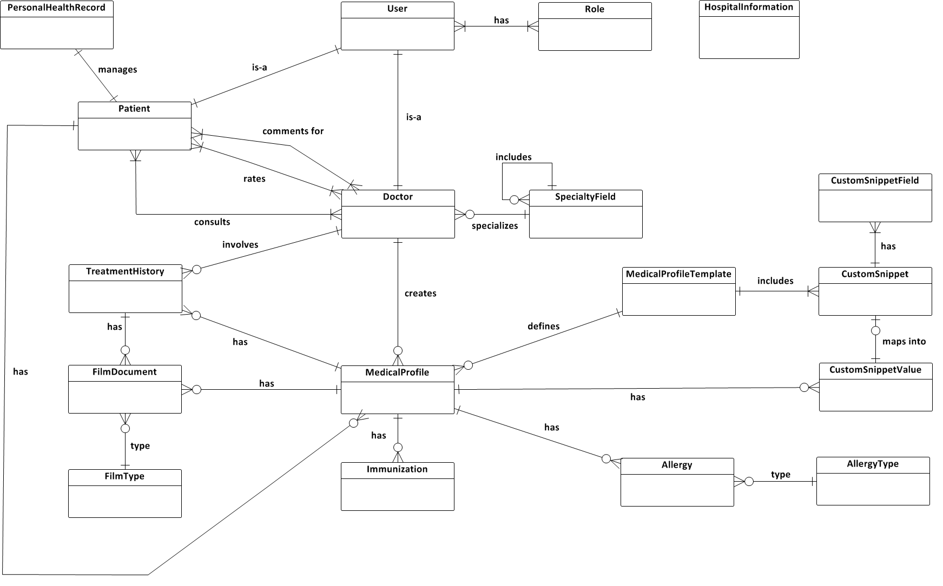

Figure Entity Relationship Diagram

## Data Dictionary

|  |  |
| --- | --- |
| **Entity Data dictionary: describe content of all entities** | |
| Entity Name | Description |
| User | Describe account of user of system. User can be: admin, patient, doctor… |
| Role | Describe role of user. |
| Doctor | Describe all doctors in system. |
| Patient | Describe all patients in system. Each patient maintain their own personal health record. |
| SpecialtyField | Manage specialty field of doctor. Currently, each doctor can be assigned to one specialty field. |
| HospitalInformation | Describe all detail information of a hospital. |
| PersonalHealthRecord | Describe some information about basic health of a patient. |
| MedicalProfileTemplate | Describe all medical profile template of hospital. They are managed by system admin. |
| CustomSnippet | Describe information to construct medical profile template |
| CustomSnippetField | Describe metadata for one CustomSnippet to easily visualize it. |
| CustomSnippetValue | Describe the value of a snippet that can be used for medical profile. |
| Immunization | Describe all immunizations that are belonged to medical profile. |
| Allergy | Describe all allergy that are belonged to medical profile. |
| AllergyType | Describe all type of allergy (Môi trường, Thức ăn, …) |
| MedicalProfile | Describe all medical profile that are defined by a medical profile template and are used for one patient. |
| TreatmentHistory | Describe all histories of treatment that are belonged to medical profile. |
| FilmDocument | Describe all film documents that are belonged to medical profile or treatment history. |
| FilmType | Describe all type of film document (X-Quang, Nội soi,…) |

# Software Design Description (SDD)

## Design Overview

* This document describes the technical and user interface design of OMCS system. It includes the architectural design, the detailed design of common functions and business functions and the design of database model.
* The architectural design describes the overall architecture of the system and the architecture of each main component.
* The detailed design describes static and dynamic structure for each component and functions. It includes class diagrams, class explanations and sequence diagrams for each use cases.
* The database design describes the relationships between entities and details of each entity.

## System Architectural Design



Figure : MVC Architecture

**(http://smist08.wordpress.com/tag/mvc/)**

**The Model** is the part of the application that handles the logic for the application data.  
Often model objects retrieve data (and store data) from a database.

**The View** is the parts of the application that handles the display of the data.  
Most often the views are created from the model data.

**The Controller** is the part of the application that handles user interaction.  
Typically controllers read data from a view, control user input, and send input data to the model.

**(**<http://www.w3schools.com/aspnet/mvc_intro.asp>**)**

## Component Diagram



Figure : Component Diagram

## Detailed Description of Components

### Class Diagram



Figure Class Diagram

### Class Diagram Explanation

#### User Model

|  |  |  |  |
| --- | --- | --- | --- |
| **Attribute Name** | **Type** | **Visibility** | **Description** |
| UserID | int | public | ID of the user |
| Username | string | public | User name of the user |
| Email | string | public | Email of the user |
| Password | string | public | Password of the user |
| FirstName | string | public | First name of the user |
| LastName | string | public | Last name of the user |
| IsActive | boolean | public | Condition of the user’s account |
| CreatedDate | datetime | public | Created date of the user’s account |
| ProfilePicture | string | public | Profile picture name of the user |
| Gender | string | public | Gender of the user |
| Birthday | datetime | public | Birthday of the user |
| Phone | string | public | Phone of the user |
| PrimaryAddress | string | public | Primary address of the user |
| SecondaryAddress | string | public | Secondary address of the user |

#### SpecialtyField Model

|  |  |  |  |
| --- | --- | --- | --- |
| **Attribute Name** | **Type** | **Visibility** | **Description** |
| SpecialtyFieldID | int | public | ID of the specialty field |
| ParentID | int | public | Parent id of the specialty field |
| Name | string | public | Name of the specialty field |

#### HospitalInformation Model

|  |  |  |  |
| --- | --- | --- | --- |
| **Attribute Name** | **Type** | **Visibility** | **Description** |
| HospitalInformationID | int | public | ID of the hospital |
| Name | string | public | Name of the hospital |
| Address | string | public | Address of the hospital |
| Email | string | public | Email of the hospital |
| Fax | string | public | Fax of the hospital |
| Phone | string | public | Phone of the hospital |
| Logo | string | public | Logo of the hospital |

#### FilmType Model

|  |  |  |  |
| --- | --- | --- | --- |
| **Field Name** | **Type** | **Visibility** | **Description** |
| FilmTypeID | int | public | ID of the film type |
| Name | string | public | Name of the film type |
| Description | string | public | Description of the film type |

#### FilmDocument Model

|  |  |  |  |
| --- | --- | --- | --- |
| **Field Name** | **Type** | **Visibility** | **Description** |
| FilmDocumentID | int | public | ID of the film document |
| TreatmentHistoryID | int | public | ID of the treatment history |
| MedicalProfileID | int | public | ID of the medical profile |
| FilmTypeId | int | public | ID of the film type |
| DateCreated | datetime | public | Date created of the film document |
| Description | string | public | Position of the film type |
| Conclusion | string | public | Path of the image |
| FilmTypePosition | string | public | Position of the film type |
| ImagePath | string | public | Path of the image |

#### CustomSnippetValue Model

|  |  |  |  |
| --- | --- | --- | --- |
| **Field Name** | **Type** | **Visibility** | **Description** |
| CustomSnippetValueID | int | public | ID of the custom snippet value |
| CustomSnippetID | int | public | ID of the custom snippet |
| MedicalProfileID | int | public | ID of the medical profile |
| Value | string | public | Value of the custom snippet |

#### TreatmentHistory Model

|  |  |  |  |
| --- | --- | --- | --- |
| **Field Name** | **Type** | **Visibility** | **Description** |
| TreatmentHistoryID | int | public | ID of the treatment history |
| MedicalProfileID | int | public | ID of the medical profile |
| TreatmentHistoryType | int | public | ID of the treatment history type |
| DoctorID | int | public | ID of the doctor |
| Symptom | string | public | Symptom of the treatment history |
| Diagnosis | string | public | Diagnosis of the treatment history |
| Treatment | string | public | Treatment of the treatment history |
| Condition | string | public | Condition of the treatment history |
| HeartRate | string | public | Heart rate of the treatment history |
| Temperature | string | public | Temperature of the treatment history |
| BloodPressure | string | public | Blood pressure of the treatment history |
| BreathingRate | string | public | Breathing rate of the treatment history |
| DateCreated | datetime | public | Created date of the treatment history |
| OnSetDate | datetime | public | Set date of the treatment history |
| Note | string | public | Note of the treatment history |

#### Doctor Model

|  |  |  |  |
| --- | --- | --- | --- |
| **Field Name** | **Type** | **Visibility** | **Description** |
| UserID | int | public | ID of the user |
| SpecialtyFieldID | int | public | ID of the specialty field |
| TreatmentHistoryID | int | public | ID of the treatment history |

#### ConversationDetail Model

|  |  |  |  |
| --- | --- | --- | --- |
| **Field Name** | **Type** | **Visibility** | **Description** |
| ConversationDetailID | int | public | ID of the conversation detail |
| ConversationID | int | public | ID of the conversation |
| UserID | int | public | ID of the user |
| Content | string | public | Content of the conversation detail |
| Attachment | string | public | Attachment of the conversation detail |
| IsRead | bit | public | Conversation detail is read |
| CreatedDate | datetime | public | Created date of the conversation detail |

#### CustomSnippet Model

|  |  |  |  |
| --- | --- | --- | --- |
| **Field Name** | **Type** | **Visibility** | **Description** |
| CustomSnippetID | int | public | ID of the custom snippet |
| MedicalProfileTemplateID | int | public | ID of the medical profile template |
| Name | string | public | Name of the custom snippet |
| Title | string | public | Title of the custom snippet |
| Position | int | public | Position of the custom snippet |
| ParentId | int | public | Parent id of the custom snippet |
| PositionInTable | int | public | Position in table of the custom snippet |
| SnippetType | int | public | Snippet type of the custom snippet |
| SnippetFieldName | string | public | Name of the snippet field |

#### MedicalProfileTemplate Model

|  |  |  |  |
| --- | --- | --- | --- |
| **Field Name** | **Type** | **Visibility** | **Description** |
| MedicalProfileTemplateID | int | public | ID of the medical profile template |
| IsDefault | string | public | Medical profile template is default |
| MedicalProfileTemplateName | string | public | Name of the medical profile template |

#### MedicalProfile Model

|  |  |  |  |
| --- | --- | --- | --- |
| **Field Name** | **Type** | **Visibility** | **Description** |
| MedicalProfileID | int | public | ID of the medical profile |
| MedicalProfileTemplateID | int | public | ID of the medical profile template |
| ParentID | int | public | Parent id of the medical profile |
| MedicalProfileKey | string | public | Key of the medical profile |
| DateCreated | datetime | public | Created date of the medical profile |

#### Conversation Model

|  |  |  |  |
| --- | --- | --- | --- |
| **Field Name** | **Type** | **Visibility** | **Description** |
| ConversationID | int | public | ID of the conversation |
| PatientID | int | public | ID of the patient |
| DoctorID | int | public | ID of the doctor |
| DateConsulted | datetime | public | Consulted date of the conversation |
| HealthProblem | string | public | Health problem of the conversation |
| Note | string | public | Note of the conversation |
| LatestContentFromPatient | string | public | Latest content from patient of the conversation |
| LatestContentFromDoctor | string | public | Latest content from doctor of the conversation |
| LatestTimeFromDoctor | datetime | public | Latest time from doctor of the conversation |
| LatestTimeFromPatient | datetime | public | Latest time from patient of the conversation |
| IsDoctorRead | bit | public | Doctor is read |
| IsPatientRead | bit | public | Patient is read |

#### Comment Model

|  |  |  |  |
| --- | --- | --- | --- |
| **Field Name** | **Type** | **Visibility** | **Description** |
| CommentID | int | public | ID of the comment |
| PatientID | int | public | ID of the patient |
| DoctorID | int | public | ID of the doctor |
| Content | string | public | Content of the comment |
| PostedDate | datetime | public | Posted date of the comment |

#### CustomSnippetField Model

|  |  |  |  |
| --- | --- | --- | --- |
| **Field Name** | **Type** | **Visibility** | **Description** |
| CustomSnippetFieldID | int | public | ID of the custom snippet field |
| CustomSnippetID | int | public | ID of the custom snippet |
| FieldID | int | public | ID of the field |
| FieldName | string | public | Field name of the custom snippet field |
| Type | string | public | Type of the custom snippet field |
| Label | string | public | Label of the custom snippet field |
| Value | string | public | Value of the custom snippet field |
| Name | string | public | Name of the custom snippet field |

#### Rating Model

|  |  |  |  |
| --- | --- | --- | --- |
| **Field Name** | **Type** | **Visibility** | **Description** |
| RatingID | int | public | ID of the rating |
| UserId | int | public | ID of the user |
| RatingPoint | float | public | Point of the rating |
| RatingFor | int | public | Rating for of the rating |
| ObjectId | int | public | ID object of the rating |

#### Allergy Model

|  |  |  |  |
| --- | --- | --- | --- |
| **Field Name** | **Type** | **Visibility** | **Description** |
| AllergyID | int | public | ID of the allergy |
| MedicalProfileID | int | public | ID of the medical profile |
| AllergyTypeID | datetime | public | ID of the allergy type |
| Name | string | public | Name of the allergy |
| DateLastOccurred | datetime | public | Last occurred date of the allergy |
| Reaction | string | public | Reaction of the allergy |
| Note | string | public | Note of the allergy |

#### Immunization Model

|  |  |  |  |
| --- | --- | --- | --- |
| **Field Name** | **Type** | **Visibility** | **Description** |
| ImmunizationId | int | public | ID of the immunization |
| MedicalProfileID | int | public | ID of the medical profile |
| Name | string | public | Name of the immunization |
| DateImmunized | datetime | public | Immunized date |
| BoosterTime | int | public | Booster time |

#### PersonalHealthRecord Model

|  |  |  |  |
| --- | --- | --- | --- |
| **Field Name** | **Type** | **Visibility** | **Description** |
| PatientId | int | public | ID of the patient |
| Height | float | public | Height of the patient |
| Weight | float | public | Weight of the patient |
| EyeColor | string | public | Eye color of the patient |
| HairColor | string | public | Hair color of the patient |
| BloodType | string | public | Blood type of the patient |
| AlcoholPerWeek | float | public | Alcohol per week of the patient |
| AlcoholNumOfYear | int | public | Alcohol number of year of the patient |
| IsBeer | bit | public | Is beer of the patient |
| SmokePackPerWeek | float | public | Smoke pack per week of the patient |
| SmokeNumOfYear | int | public | Smoke number of year of the patient |
| SportName | string | public | Sport name of the patient |
| SportPerWeek | string | public | Sport per week of the patient |
| ExerciseType | string | public | Exercise type of the patient |
| ExercisePerWeek | int | public | Exercise per week of the patient |

#### AllergyType Model

|  |  |  |  |
| --- | --- | --- | --- |
| **Field Name** | **Type** | **Visibility** | **Description** |
| AllergyTypeID | int | public | ID of the allergy type |
| Name | float | public | Name of the allergy type |
| Description | float | public | Description of the allergy type |

#### Patient Model

|  |  |  |  |
| --- | --- | --- | --- |
| **Field Name** | **Type** | **Visibility** | **Description** |
| UserID | int | public | ID of the user |
| Ethnicity | string | public | Ethnicity of the patient |
| Nationality | string | public | Nationality of the patient |
| Job | string | public | Job of the patient |
| WhereToWork | string | public | Where to work of the patient |
| ContactPerson | string | public | Contact person of the patient |
| ContactPersonAddress | string | public | Contact person address of the patient |
| ContactPersonPhone | string | public | Contact person phone of the patient |
| HealthInsuranceId | int | public | Health insurance id of the patient |
| HealthInsuranceIssued | datetime | public | Health insurance issued of the patient |
| HealthInsuranceDateExpired | datetime | public | Health insurance date expired of the patient |

#### Role Model

|  |  |  |  |
| --- | --- | --- | --- |
| **Field Name** | **Type** | **Visibility** | **Description** |
| RoleID | int | public | ID of the role |
| RoleName | string | public | Name of the role |
| Description | string | public | Description of the role |

#### UserRole Model

|  |  |  |  |
| --- | --- | --- | --- |
| **Field Name** | **Type** | **Visibility** | **Description** |
| UserID | int | public | ID of the user |
| RoleID | int | public | ID of the role |

## Sequence Diagram

### <Guest> Login



Figure : <Guest> Login Sequence Diagram

### <Guest> Register



Figure : <Guest> Register Sequence Diagram

### <Authorized User> Change Password



Figure : <Authorized User> Change Password Sequence Diagram

### <Authorized User> Change Profile Picture



Figure : <Authorized User> Change Profile Picture Sequence Diagram

### <Patient> Conversation



Figure : <Patient> Conversation Sequence Diagram

### <Doctor> Request Webcam



Figure : <Doctor> Request Webcam Sequence Diagram

### <Patient> Upload Attachment



Figure : <Patient> Upload Attachment

### <Admin> Define New Medical Profile Template



Figure <Admin> Define New Medical Profile Template

### <Admin> Update Medical Profile Template



Figure <Admin> Update Medical Profile Template

### <Doctor> Update Medical Profile

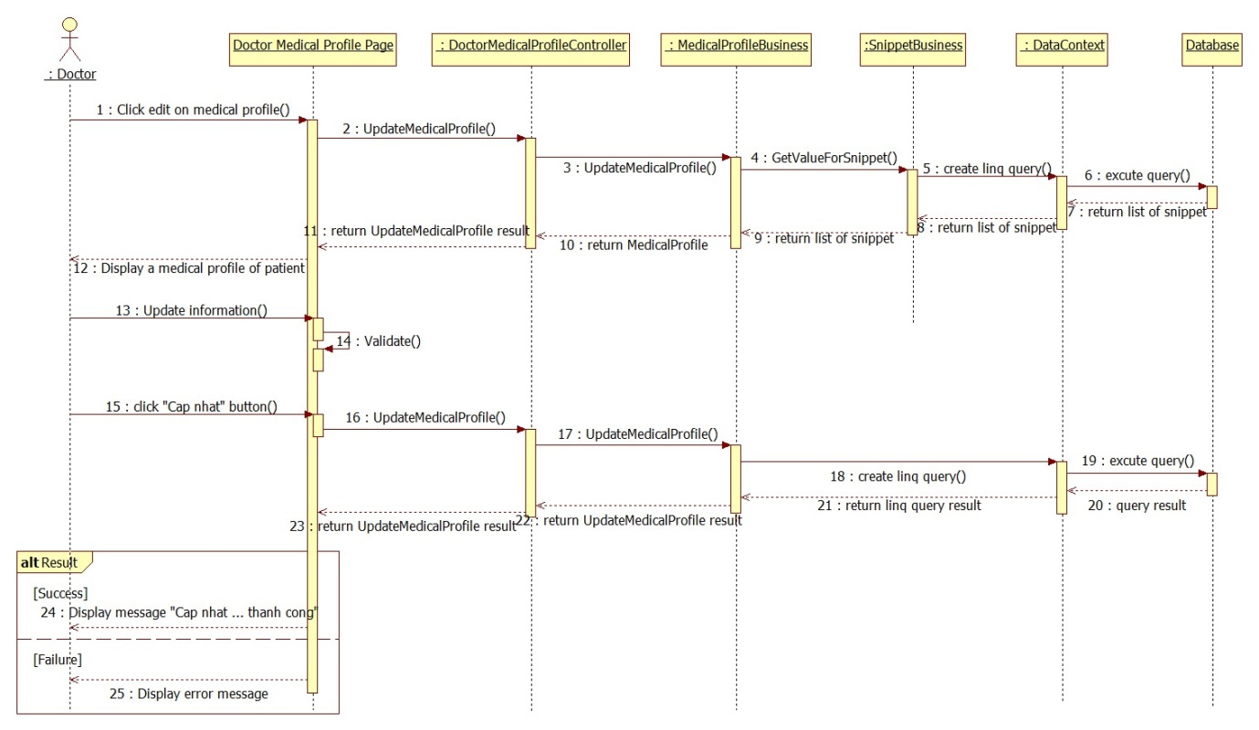

Figure : <Doctor> Update Medical Profile

### <Doctor> Views Medical Profile



Figure : <Doctor> Views Medical Profile

### <Patient> Update Personal Health Record



Figure : <Patient> Update Personal Health Record

### <Patient> View Medical Profile



Figure 9: <Patient> View Medical Profile Record

## 

## User Interface Design

### Homepage screen

#### Screen Images

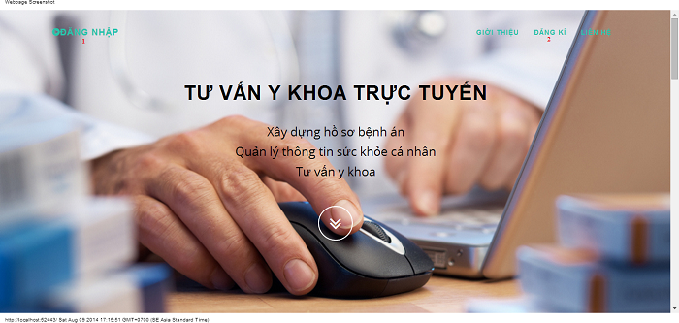

#### Objects and Actions

##### Actions

|  |  |  |  |  |  |
| --- | --- | --- | --- | --- | --- |
| **Field No** | **Field name** | **Type** | **Action** | **Description** | **Validation** |
| 1 | Đăng nhập | Link | On click | Forward to “Login” page |  |
| 2 | Đăng kí | Link | On click | Forward to “Register” page |  |

### Login screen

#### Screen image

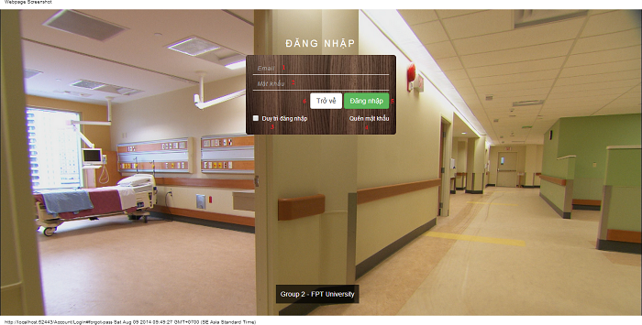

#### Objects and Actions

##### Data fields

|  |  |  |  |  |  |  |
| --- | --- | --- | --- | --- | --- | --- |
| **Field No** | **Field name** | **Type** | **Mandatory** | **Data type** | **Max length** | **Description** |
| 1 | Email | Textbox | Yes | String |  | Contain user’s email to login |
| 2 | Mật khẩu | Textbox | Yes | String |  | Contain user’s password to login |
| 3 | Duy trì đăng nhập | Checkbox | No | Boolean |  | Check to remember user to login again |

##### Actions

|  |  |  |  |  |  |
| --- | --- | --- | --- | --- | --- |
| **Field No** | **Field name** | **Type** | **Action** | **Description** | **Validation** |
| 4 | Quên mật khẩu | Link | On click | Forward to popup “ForgotPassword”. |  |
| 5 | Đăng nhập | Button | On click | Forward to page follow user’s role. | Email and password not empty |
| 6 | Trở về | Button | On click | Cancel the login. Back to previous page. |  |

### Register screen

#### Screen image

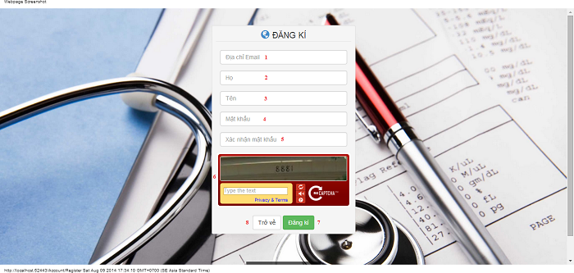

#### Objects and Actions

##### Data fields

|  |  |  |  |  |  |  |
| --- | --- | --- | --- | --- | --- | --- |
| **Field No** | **Field name** | **Type** | **Mandatory** | **Data type** | **Max length** | **Description** |
| 1 | Địa chỉ Email | Textbox | Yes | String | 50 | Contain user’s email to login |
| 2 | Họ | Textbox | Yes | String | 25 | Contain user’s last name |
| 3 | Tên | Textbox | Yes | String | 25 | Contain user’s first name |
| 4 | Mật khẩu | Textbox | Yes | String | 25 | Contain user’s password to login |
| 5 | Xác nhận mật khẩu | Textbox | Yes | String | 25 | Contain the confirm password |
| 6 | Retype Image | Textbox | Yes | String |  | Contain the verifying captcha |

##### Actions

|  |  |  |  |  |  |
| --- | --- | --- | --- | --- | --- |
| **Field No** | **Field name** | **Type** | **Action** | **Description** | **Validation** |
| 7 | Đăng kí | Button | On click | Submit inputted data to server | Inputted data must be valid |
| 8 | Trở về | Button | On click | Cancel the registration. Back to previous page |  |

### Forgot password screen

#### Screen image

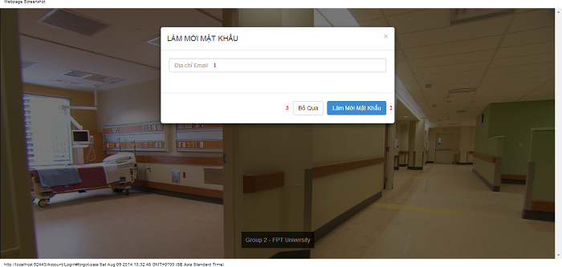

#### Objects and Actions

##### Data fields

|  |  |  |  |  |  |  |
| --- | --- | --- | --- | --- | --- | --- |
| **Field No** | **Field name** | **Type** | **Mandatory** | **Data type** | **Max length** | **Description** |
| 1 | Địa chỉ Email | Textbox | Yes | String |  | Contain user’s email to reset password |

##### Actions

|  |  |  |  |  |  |
| --- | --- | --- | --- | --- | --- |
| **Field No** | **Field name** | **Type** | **Action** | **Description** | **Validation** |
| 2 | Làm mới mật khẩu | Button | On click | Submit inputted data to server | Inputted data must be valid |
| 3 | Bỏ qua | Button | On click | Dismiss model. Back to login page |  |

### Admin hospital information screen

#### Screen image

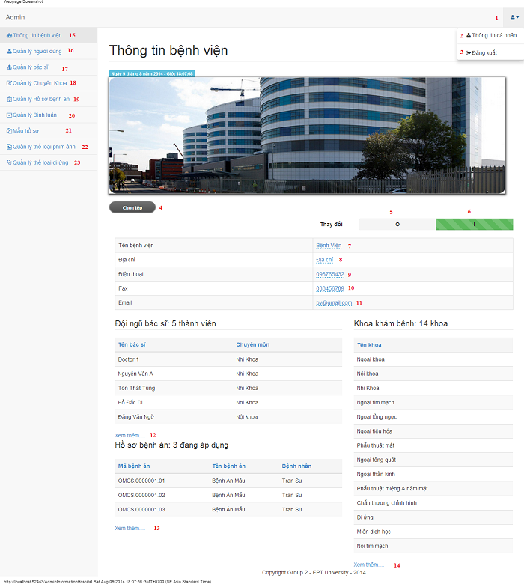

#### Objects and Actions

##### Data fields

|  |  |  |  |  |  |  |
| --- | --- | --- | --- | --- | --- | --- |
| **Field No** | **Field name** | **Type** | **Mandatory** | **Data type** | **Max length** | **Description** |
| 7 | Tên bệnh viện | Textbox | Yes | String | 50 | Contain hospital’s name |
| 8 | Địa chỉ | Textbox | Yes | String | 50 | Contain hospital’s address |
| 9 | Điện thoại | Textbox | Yes | String | 12 | Contain hospital’s phone |
| 10 | Fax | Textbox | Yes | String | 12 | Contain hospital’s fax |
| 11 | Email | Textbox | Yes | String | 50 | Contain hospital’s email |

##### Actions

|  |  |  |  |  |  |
| --- | --- | --- | --- | --- | --- |
| **Field No** | **Field name** | **Type** | **Action** | **Description** | **Validation** |
| 1 |  | DDL | On click | List “Thông tin cá nhân” and “Đăng xuất” |  |
| 2 | Thông tin cá nhân | Link | On click | Forward to “AdminInformation” page |  |
| 3 | Đăng xuất | Link | On click | Back to login page |  |
| 4 | Chọn tệp | File | On click | Submit inputted file to server |  |
| 5 | 0 | Checkbox | On click | Click “0” to view table hospital information |  |
| 6 | I | Checkbox | On click | Click “I” to edit table data hospital information |  |
| 12 | Xem thêm… | Link | On click | Forward to “AdminDoctor” page |  |
| 13 | Xem thêm… | Link | On click | Forward to “AdminMedicalProfile” page |  |
| 14 | Xem thêm… | Link | On click | Forward to “AdminSpecialtyField” page |  |
| 15 | Thông tin bệnh viện | Link | On click | Forward to “AdminInformationHospital” page |  |
| 16 | Quản lý người dùng | Link | On click | Forward to “AdminUser” page |  |
| 17 | Quản lý bác sĩ | Link | On click | Forward to “AdminDoctor” page |  |
| 18 | Quản lý chuyên khoa | Link | On click | Forward to “AdminSpecialtyField” page |  |
| 19 | Quản lý hồ sơ bệnh án | Link | On click | Forward to “AdminMedicalProfile” page |  |
| 20 | Quản lý bình luận | Link | On click | Forward to “AdminComment” page |  |
| 21 | Mẫu hồ sơ | Link | On click | Forward to “AdminTemplate” page |  |
| 22 | Quản lý thể loại phim ảnh | Link | On click | Forward to “FilmType” page |  |
| 23 | Quản lý thể loại dị ứng | Link | On click | Forward to “AllergyType” page |  |

### Admin information screen

#### Screen image

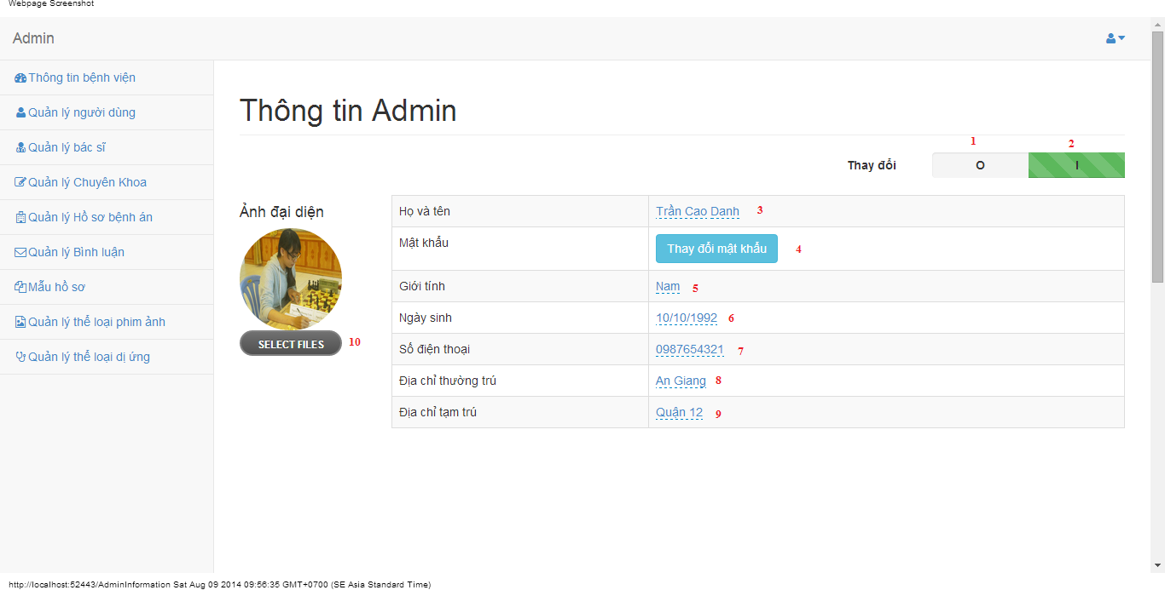

#### Objects and Actions

##### Data fields

|  |  |  |  |  |  |  |
| --- | --- | --- | --- | --- | --- | --- |
| **Field No** | **Field name** | **Type** | **Mandatory** | **Data type** | **Max length** | **Description** |
| 3 | Họ và tên | Textbox | Yes | String | 50 | Contain user’s full name |
| 5 | Giới tính | List | Yes | String | 50 | Contain user’s gender |
| 6 | Ngày sinh | Textbox | Yes | Date | 12 | Contain user’s birthday |
| 7 | Số điện thoại | Textbox | Yes | String | 12 | Contain user’s phone |
| 8 | Địa chỉ thường trú | Textbox | Yes | String | 50 | Contain user’s primary address |
| 9 | Địa chỉ tạm trú | Textbox | No | String | 50 | Contain user’s secondary address |

##### Actions

|  |  |  |  |  |  |
| --- | --- | --- | --- | --- | --- |
| **Field No** | **Field name** | **Type** | **Action** | **Description** | **Validation** |
| 1 | 0 | Checkbox | On click | Click “0” to view table admin information |  |
| 2 | I | Checkbox | On click | Click “I” to edit table data admin information |  |
| 4 | Thay đổi mật khẩu | Button | On click | Forward to popup “ChangePassword” |  |
| 10 | Chọn tệp | File | On click | Submit inputted file to server |  |

### Manage users screen

#### Screen image

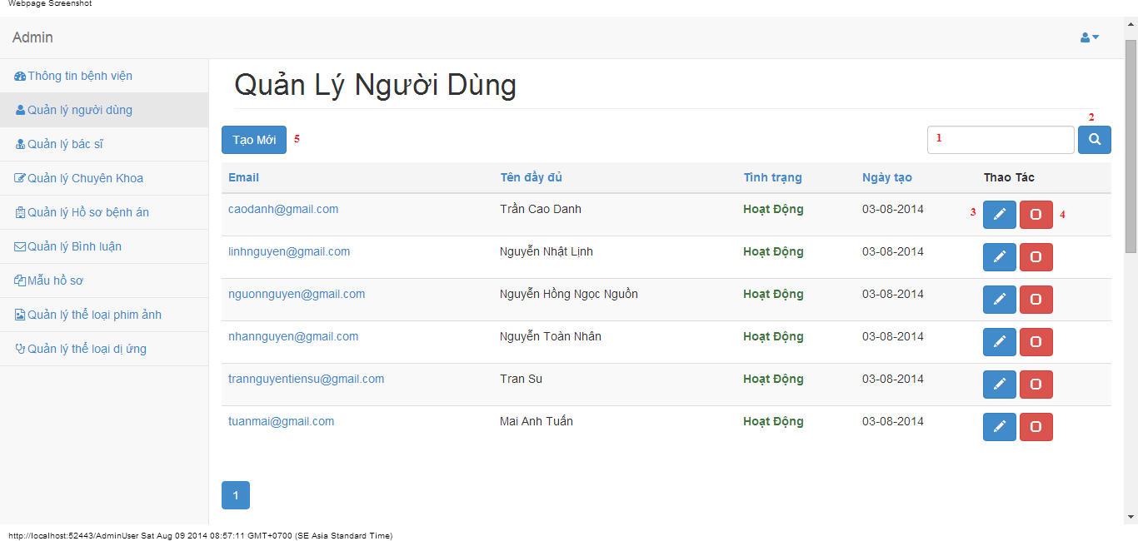

#### Objects and Actions

##### Data fields

|  |  |  |  |  |  |  |
| --- | --- | --- | --- | --- | --- | --- |
| **Field No** | **Field name** | **Type** | **Mandatory** | **Data type** | **Max length** | **Description** |
| 1 | Search | Textbox | No | String | 50 | Contain search condition to find some user account |

##### Actions

|  |  |  |  |  |  |
| --- | --- | --- | --- | --- | --- |
| **Field No** | **Field name** | **Type** | **Action** | **Description** | **Validation** |
| 2 | Tìm | Button | On click | Send inputted search condition to server |  |
| 3 | Cập nhật | Button | On click | Forward to popup “Edit” |  |
| 4 | Vô hiệu/Kích hoạt | Link | On click | Deactivate user or Activate user |  |
| 5 | Tạo mới | Button | On click | Forward to popup “Create” |  |

### Create user screen

#### Screen image

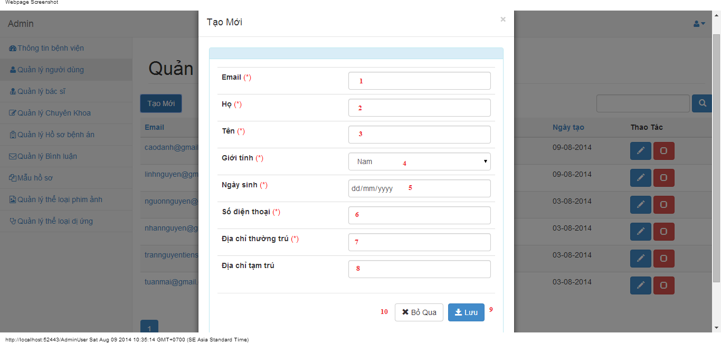

#### Objects and Actions

##### Data fields

|  |  |  |  |  |  |  |
| --- | --- | --- | --- | --- | --- | --- |
| **Field No** | **Field name** | **Type** | **Mandatory** | **Data type** | **Max length** | **Description** |
| 1 | Email | Textbox | Yes | String | 50 | Contain user’s email |
| 2 | Họ | Textbox | Yes | String | 50 | Contain user’s last name |
| 3 | Tên | Textbox | Yes | String | 50 | Contain user’s first name |
| 4 | Giới tính | Textbox | Yes | String |  | Contain user’s gender |
| 5 | Ngày sinh | Textbox | Yes | Date |  | Contain user’s birthday |
| 6 | Số điện thoại | Textbox | Yes | String | 12 | Contain user’s phone |
| 7 | Địa chỉ thường trú | Textbox | Yes | String | 50 | Contain user’s primary address |
| 8 | Địa chỉ tạm trú | Textbox | No | String | 50 | Contain user’s secondary address |

##### Actions

|  |  |  |  |  |  |
| --- | --- | --- | --- | --- | --- |
| **Field No** | **Field name** | **Type** | **Action** | **Description** | **Validation** |
| 9 | Lưu | Button | On click | Submit inputted data to server | Inputted data must be valid |
| 10 | Bỏ qua | Button | On click | Dismiss popup |  |

### Edit user screen

#### Screen image

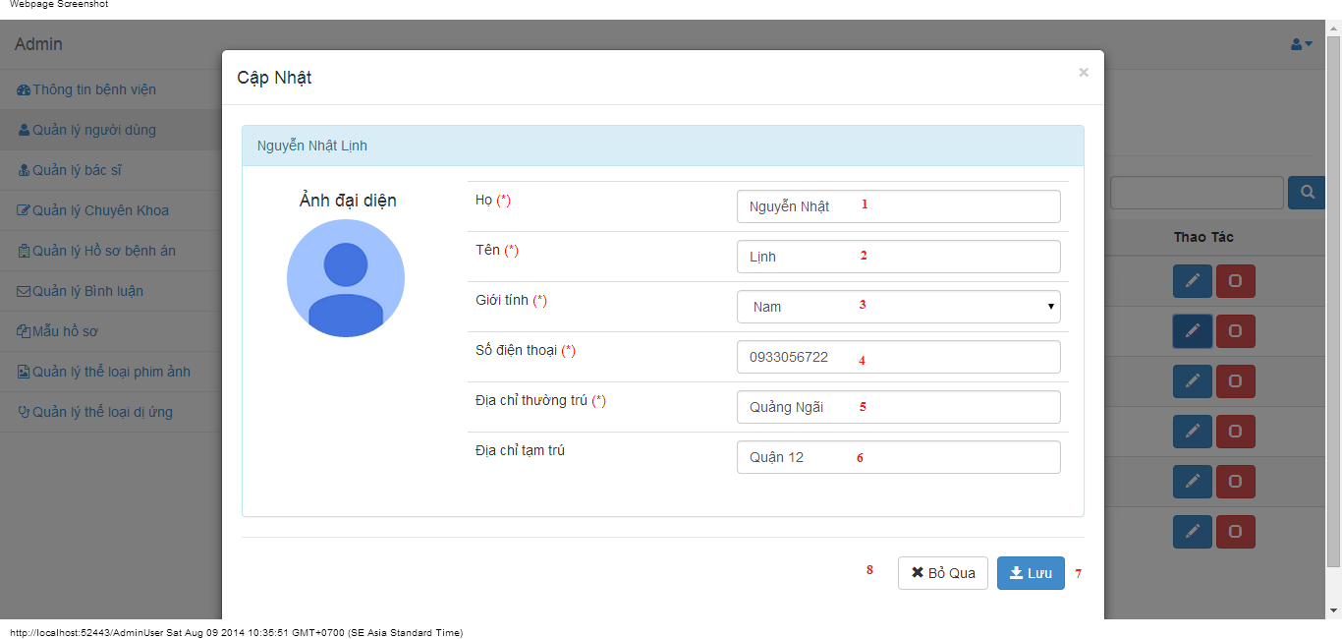

#### Objects and Actions

##### Data fields

|  |  |  |  |  |  |  |
| --- | --- | --- | --- | --- | --- | --- |
| **Field No** | **Field name** | **Type** | **Mandatory** | **Data type** | **Max length** | **Description** |
| 1 | Họ | Textbox | Yes | String | 50 | Contain user’s last name |
| 2 | Tên | Textbox | Yes | String | 50 | Contain user’s first name |
| 3 | Giới tính | Textbox | Yes | String |  | Contain user’s gender |
| 4 | Số điện thoại | Textbox | Yes | String | 12 | Contain user’s phone |
| 5 | Địa chỉ thường trú | Textbox | Yes | String | 50 | Contain user’s primary address |
| 6 | Địa chỉ tạm trú | Textbox | No | String | 50 | Contain user’s secondary address |

##### Actions

|  |  |  |  |  |  |
| --- | --- | --- | --- | --- | --- |
| **Field No** | **Field name** | **Type** | **Action** | **Description** | **Validation** |
| 7 | Lưu | Button | On click | Submit inputted data to server | Inputted data must be valid |
| 8 | Bỏ qua | Button | On click | Dismiss popup |  |

### Manage doctors screen

#### Screen image

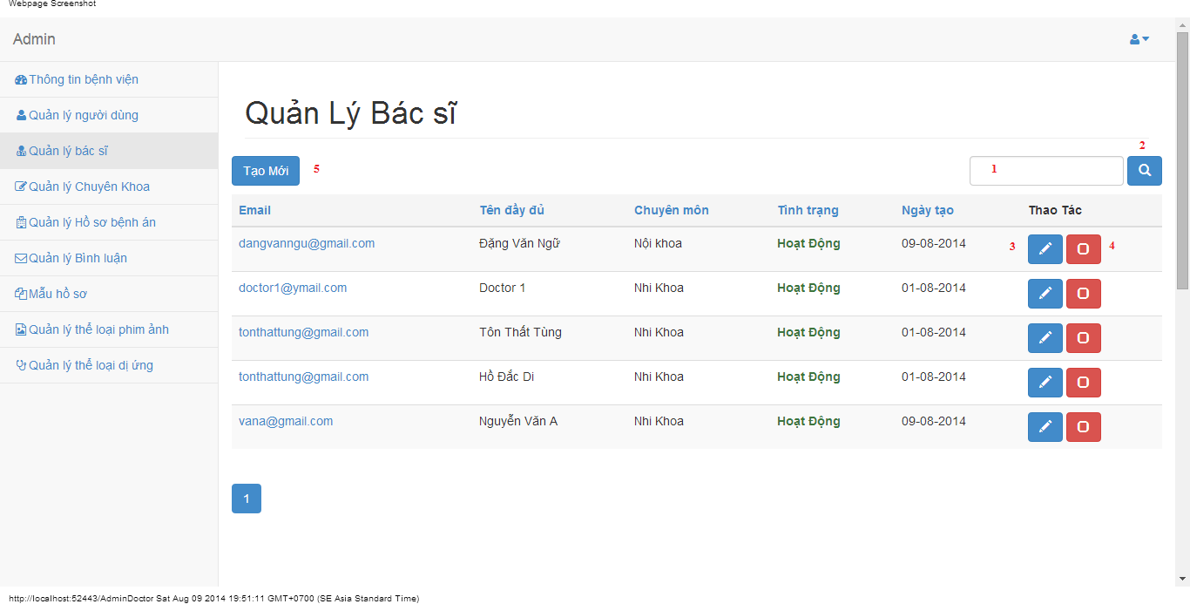

#### Objects and Actions

##### Data fields

|  |  |  |  |  |  |  |
| --- | --- | --- | --- | --- | --- | --- |
| **Field No** | **Field name** | **Type** | **Mandatory** | **Data type** | **Max length** | **Description** |
| 1 | Search | Textbox | No | String | 50 | Contain search condition to find some user account |

##### Actions

|  |  |  |  |  |  |
| --- | --- | --- | --- | --- | --- |
| **Field No** | **Field name** | **Type** | **Action** | **Description** | **Validation** |
| 2 | Tìm | Button | On click | Send inputted search condition to server |  |
| 3 | Cập nhật | Button | On click | Forward to popup “Edit” |  |
| 4 | Vô hiệu/Kích hoạt | Link | On click | Deactivate user or Activate user |  |
| 5 | Tạo mới | Button | On click | Forward to popup “Create” |  |

### Create doctor screen

#### Screen image

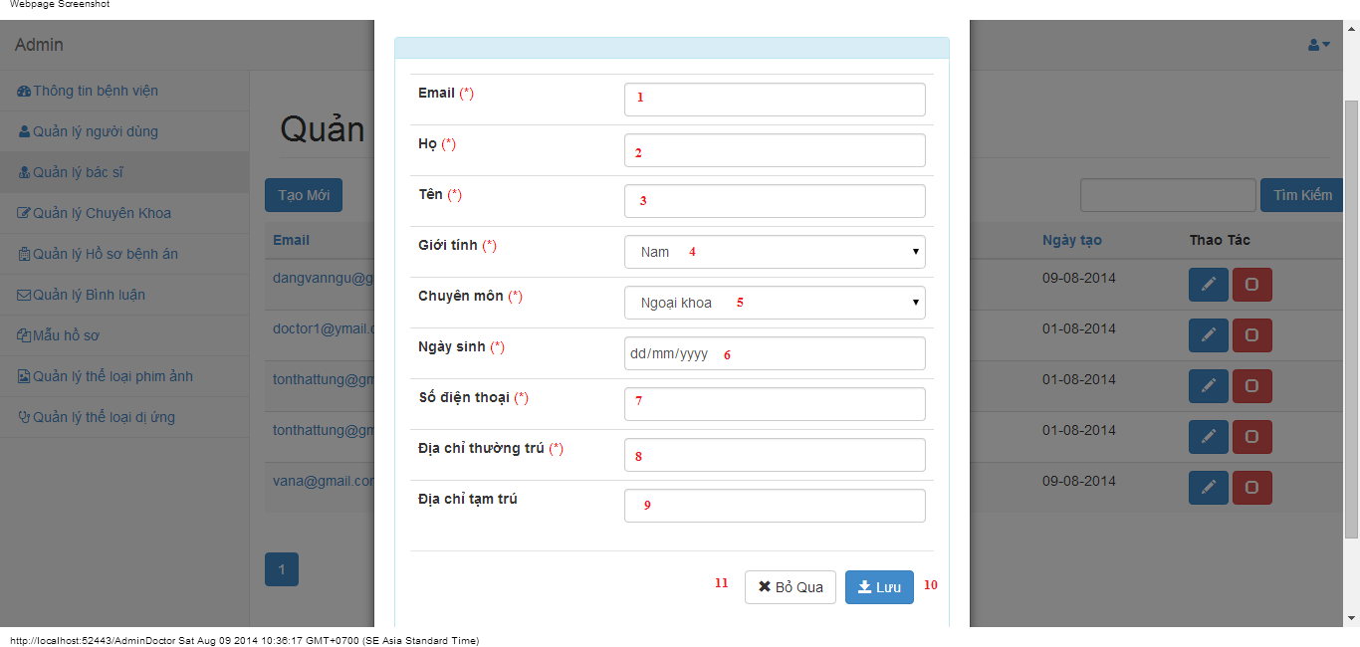

#### Objects and Actions

##### Data fields

|  |  |  |  |  |  |  |
| --- | --- | --- | --- | --- | --- | --- |
| **Field No** | **Field name** | **Type** | **Mandatory** | **Data type** | **Max length** | **Description** |
| 1 | Email | Textbox | Yes | String | 50 | Contain user’s email |
| 2 | Họ | Textbox | Yes | String | 50 | Contain user’s last name |
| 3 | Tên | Textbox | Yes | String | 50 | Contain user’s first name |
| 4 | Giới tính | Textbox | Yes | String |  | Contain user’s gender |
| 5 | Chuyên môn | DDL | Yes | String |  | Contain user’s specialty field |
| 6 | Ngày sinh | Textbox | Yes | Date |  | Contain user’s birthday |
| 7 | Số điện thoại | Textbox | Yes | String | 12 | Contain user’s phone |
| 8 | Địa chỉ thường trú | Textbox | Yes | String | 50 | Contain user’s primary address |
| 9 | Địa chỉ tạm trú | Textbox | No | String | 50 | Contain user’s secondary address |

##### Actions

|  |  |  |  |  |  |
| --- | --- | --- | --- | --- | --- |
| **Field No** | **Field name** | **Type** | **Action** | **Description** | **Validation** |
| 9 | Lưu | Button | On click | Submit inputted data to server |  |
| 10 | Bỏ qua | Button | On click | Dismiss popup |  |

### Edit doctor screen

#### Screen image

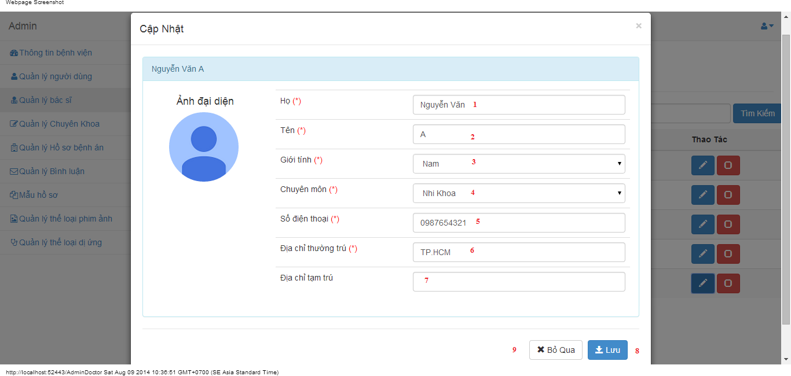

#### Objects and Actions

##### Data fields

|  |  |  |  |  |  |  |
| --- | --- | --- | --- | --- | --- | --- |
| **Field No** | **Field name** | **Type** | **Mandatory** | **Data type** | **Max length** | **Description** |
| 1 | Họ | Textbox | Yes | String | 50 | Contain user’s last name |
| 2 | Tên | Textbox | Yes | String | 50 | Contain user’s first name |
| 3 | Giới tính | Textbox | Yes | String |  | Contain user’s gender |
| 4 | Chuyên môn | DDL | Yes | String |  | Contain user’s specialty field |
| 5 | Số điện thoại | Textbox | Yes | String | 12 | Contain user’s phone |
| 6 | Địa chỉ thường trú | Textbox | Yes | String | 50 | Contain user’s primary address |
| 7 | Địa chỉ tạm trú | Textbox | No | String | 50 | Contain user’s secondary address |

##### Actions

|  |  |  |  |  |  |
| --- | --- | --- | --- | --- | --- |
| **Field No** | **Field name** | **Type** | **Action** | **Description** | **Validation** |
| 7 | Lưu | Button | On click | Submit inputted data to server | Inputted data must be valid |
| 8 | Bỏ qua | Button | On click | Dismiss popup |  |

### Manage medical profiles screen

#### Screen image

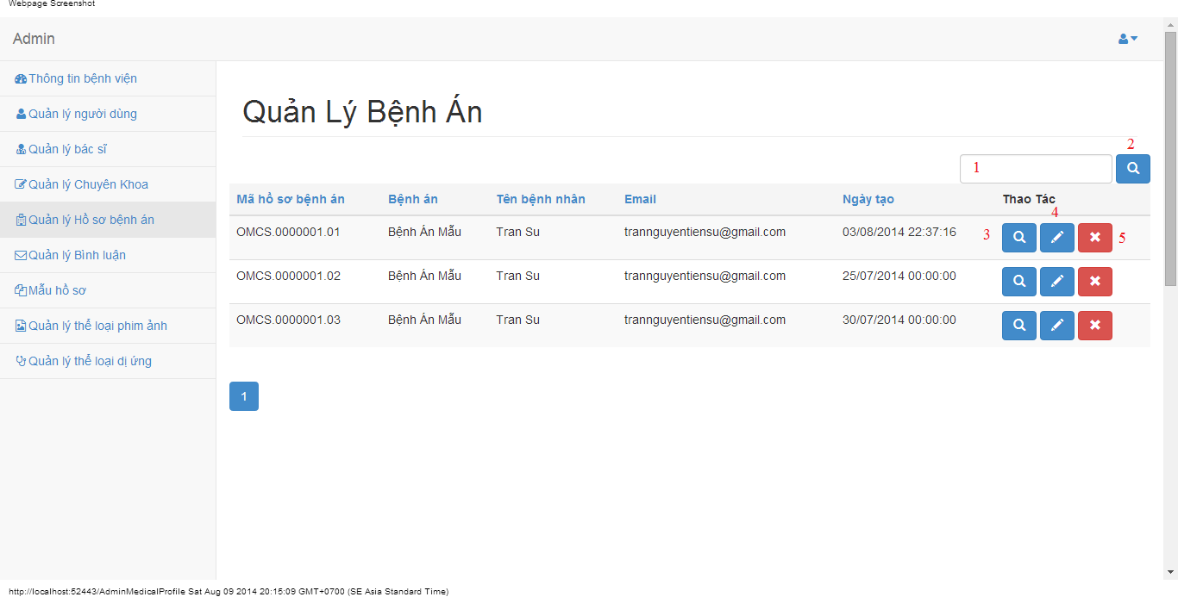

#### Objects and Actions

##### Data fields

|  |  |  |  |  |  |  |
| --- | --- | --- | --- | --- | --- | --- |
| **Field No** | **Field name** | **Type** | **Mandatory** | **Data type** | **Max length** | **Description** |
| 1 | Search | Textbox | No | String | 50 | Contain search condition to find some medical profile |

##### Actions

|  |  |  |  |  |  |
| --- | --- | --- | --- | --- | --- |
| **Field No** | **Field name** | **Type** | **Action** | **Description** | **Validation** |
| 2 | Tìm | Button | On click | Send inputted search condition to server |  |
| 3 | Xem chi tiết | Button | On click | Forward to “Details” page |  |
| 4 | Cập nhật | Link | On click | Forward to “UpdateMedicalProfile” page |  |
| 5 | Xóa | Button | On click | Delete a medical profile |  |

### View medical profile screen

#### Screen image

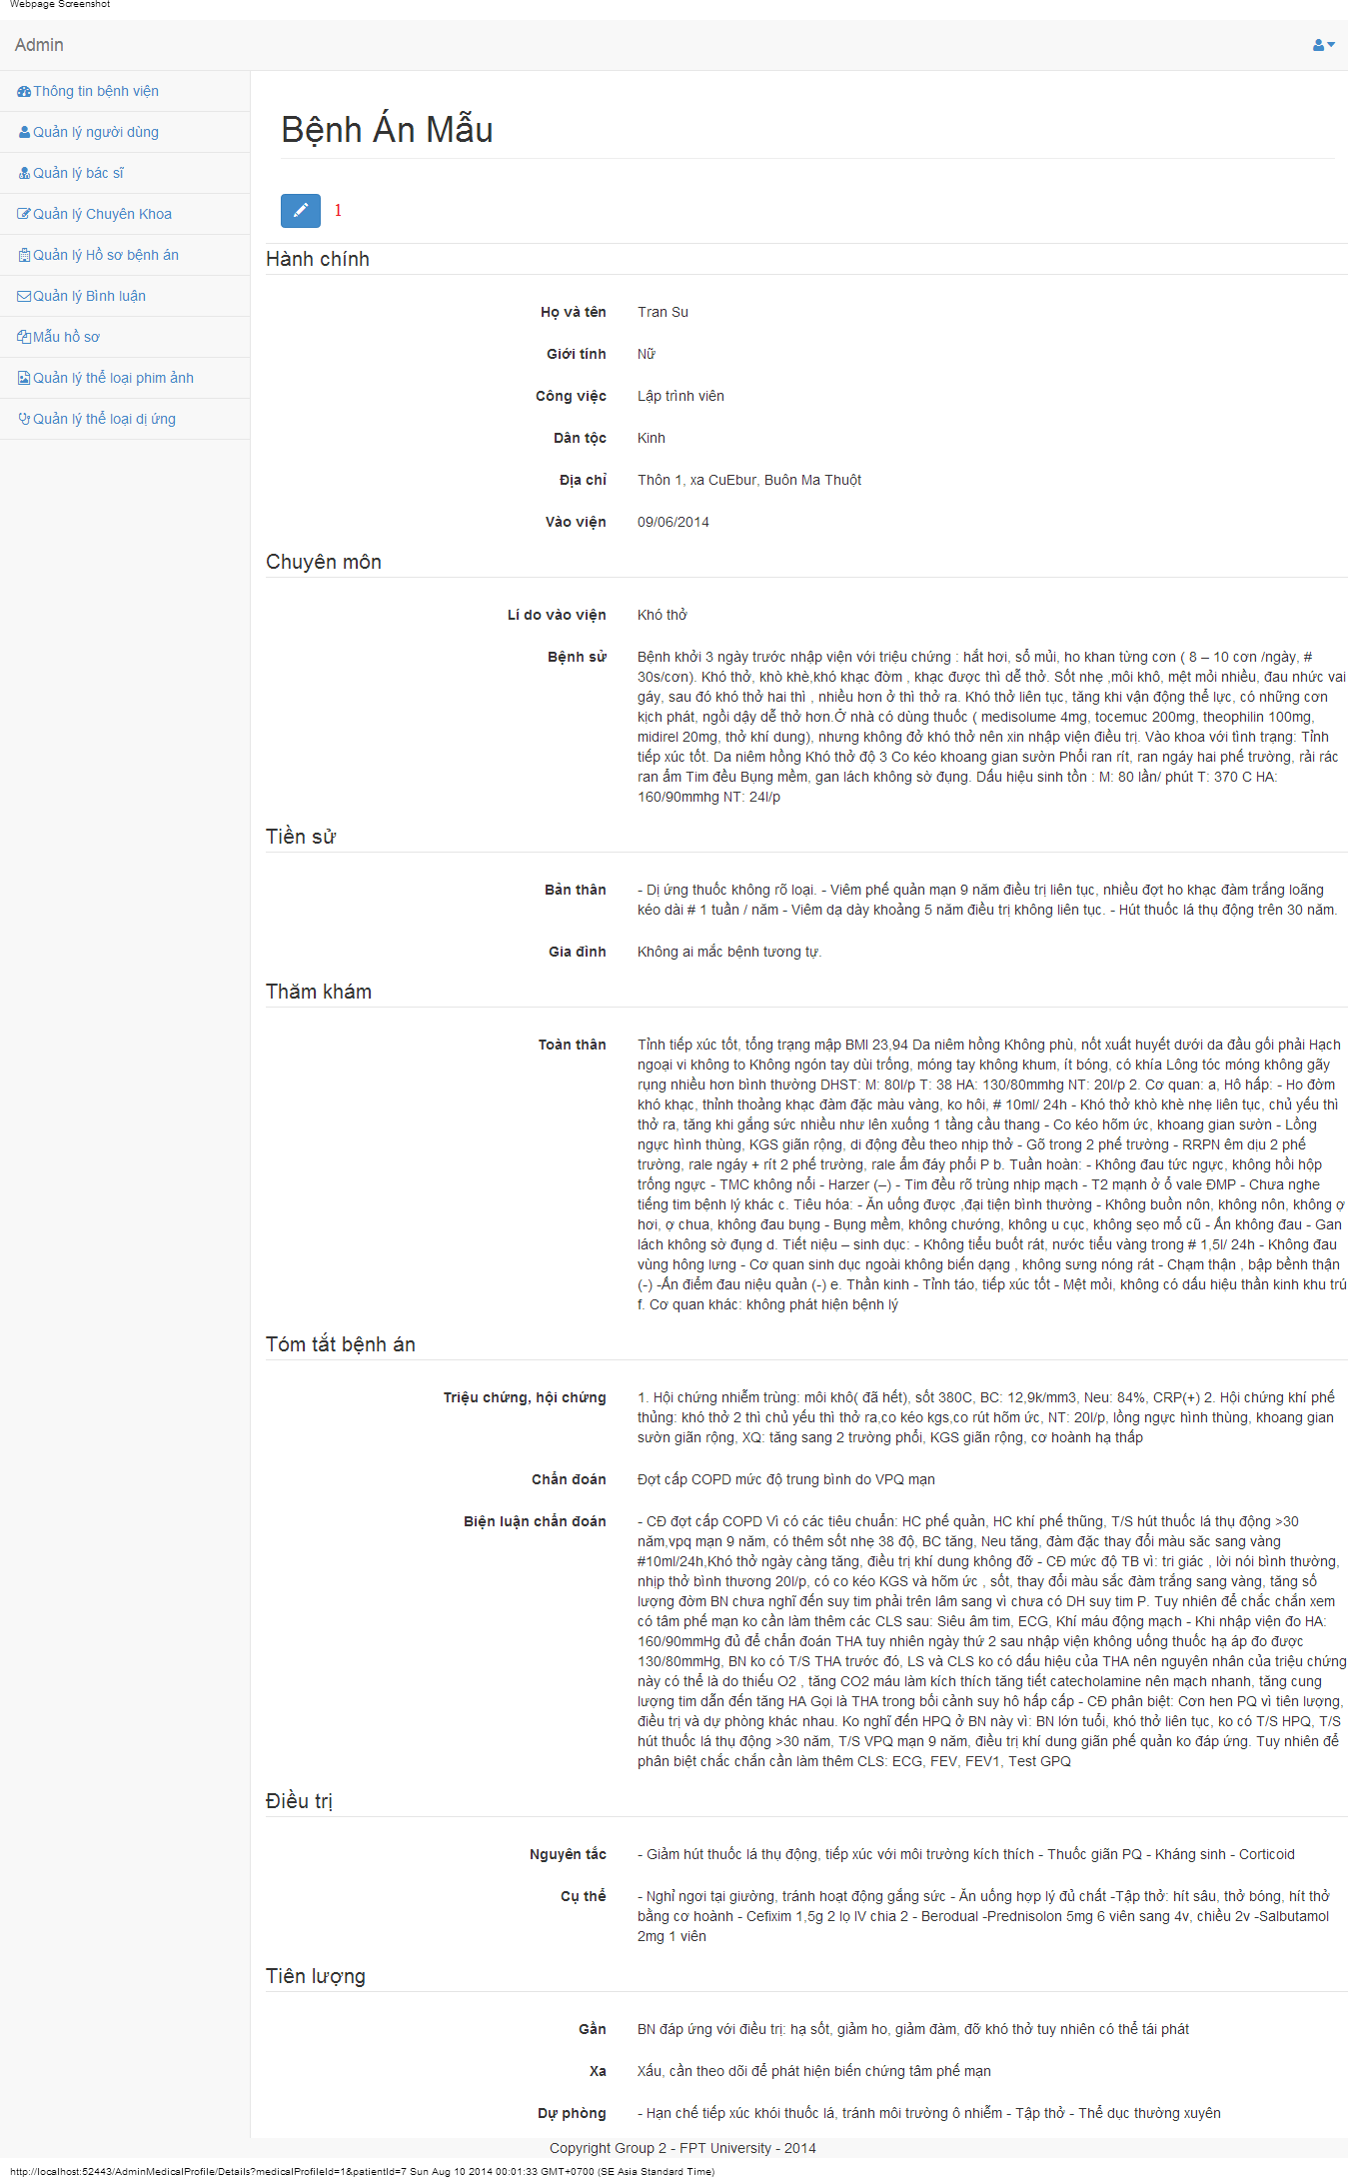

#### Objects and Actions

##### Actions

|  |  |  |  |  |  |
| --- | --- | --- | --- | --- | --- |
| **Field No** | **Field name** | **Type** | **Action** | **Description** | **Validation** |
| 1 | Cập nhật | Link | On click | Forward to “UpdateMedicalProfile” page |  |

### Update medical profile screen

#### Screen image

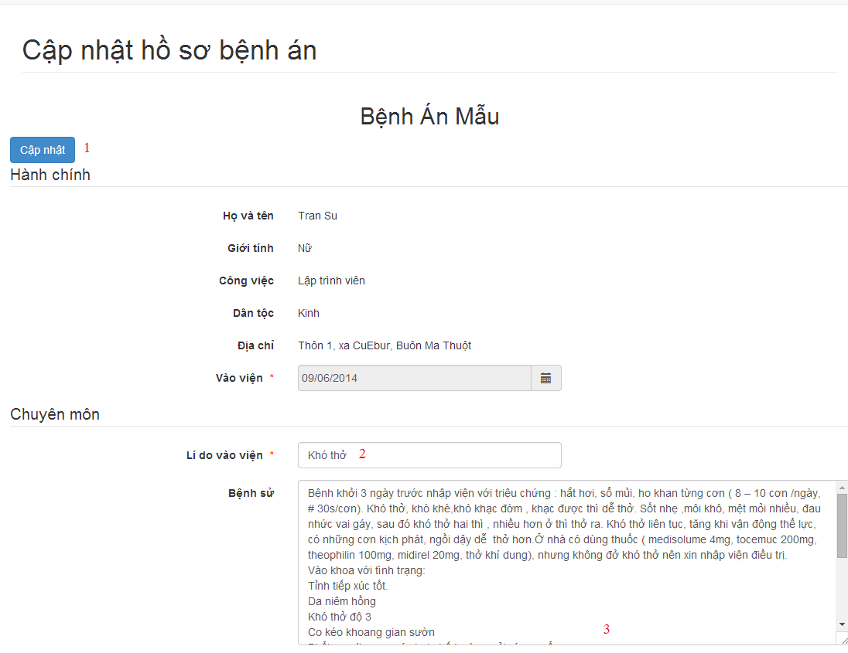

#### Objects and Actions

##### Data fields

|  |  |  |  |  |  |  |
| --- | --- | --- | --- | --- | --- | --- |
| **Field No** | **Field name** | **Type** | **Mandatory** | **Data type** | **Max length** | **Description** |
| 2 | Lí do vào viện | Textbox | Yes | String |  | Contain input follow medical profile template |
| 3 | Bệnh sử | Textbox | Yes | String |  | Contain input follow medical profile template |

##### Actions

|  |  |  |  |  |  |
| --- | --- | --- | --- | --- | --- |
| **Field No** | **Field name** | **Type** | **Action** | **Description** | **Validation** |
| 1 | Cập nhật | Link | On click | Submit inputted data to server |  |

### Manage medical profiles screen

#### Screen image

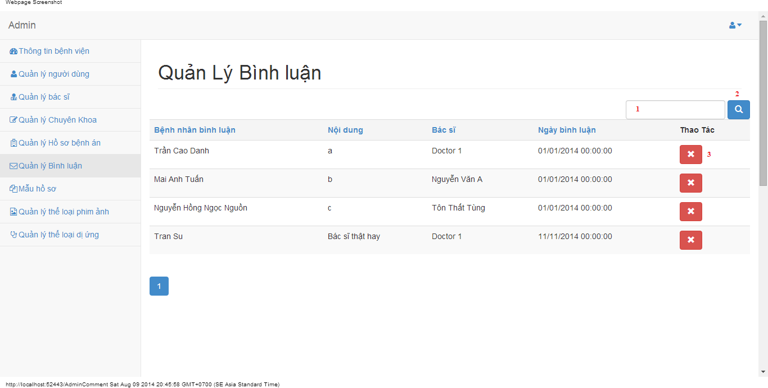

#### Objects and Actions

##### Data fields

|  |  |  |  |  |  |  |
| --- | --- | --- | --- | --- | --- | --- |
| **Field No** | **Field name** | **Type** | **Mandatory** | **Data type** | **Max length** | **Description** |
| 1 | Search | Textbox | No | String | 50 | Contain search condition to find some user account |

##### Actions

|  |  |  |  |  |  |
| --- | --- | --- | --- | --- | --- |
| **Field No** | **Field name** | **Type** | **Action** | **Description** | **Validation** |
| 2 | Tìm | Button | On click | Send inputted search condition to server |  |
| 3 | Xóa | Button | On click | Delete a comment |  |

### Manage medical profile templates screen

#### Screen image

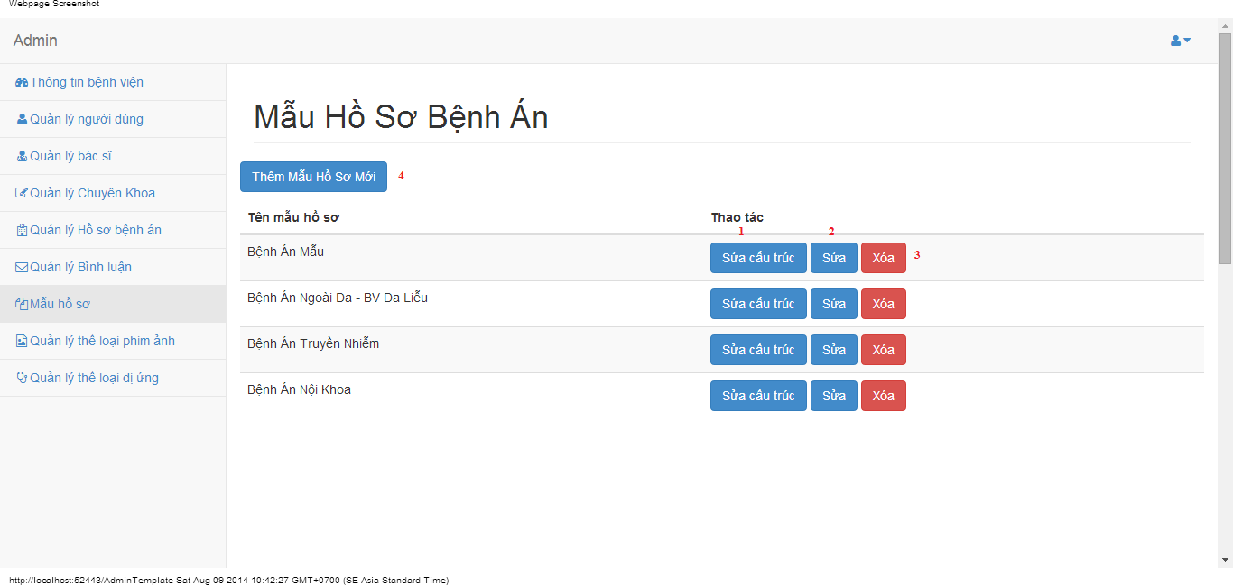

#### Objects and Actions

##### Actions

|  |  |  |  |  |  |
| --- | --- | --- | --- | --- | --- |
| **Field No** | **Field name** | **Type** | **Action** | **Description** | **Validation** |
| 1 | Sửa cấu trúc | Button | On click | Forward to “Editor” page |  |
| 2 | Sửa | Button | On click | Forward to popup “Edit” |  |
| 3 | Xóa | Button | On click | Delete a medical profile template |  |
| 4 | Thêm mẫu hồ sơ mới | Button | On click | Forward to popup “Create” |  |

### Edit medical profile templates screen

#### Screen image

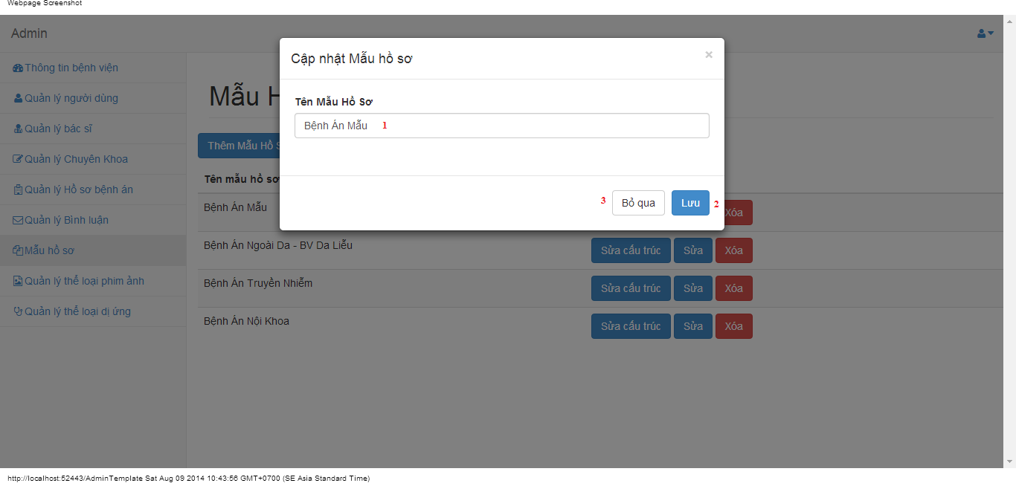

#### Objects and Actions

##### Data fields

|  |  |  |  |  |  |  |
| --- | --- | --- | --- | --- | --- | --- |
| **Field No** | **Field name** | **Type** | **Mandatory** | **Data type** | **Max length** | **Description** |
| 1 | Tên mẫu hồ sơ | Textbox | Yes | String | 50 | Contain name medical profile |

##### Actions

|  |  |  |  |  |  |
| --- | --- | --- | --- | --- | --- |
| **Field No** | **Field name** | **Type** | **Action** | **Description** | **Validation** |
| 9 | Lưu | Button | On click | Submit inputted data to server | Inputted data must be valid |
| 10 | Bỏ qua | Button | On click | Dismiss popup |  |

### Add medical profile templates screen

#### Screen image

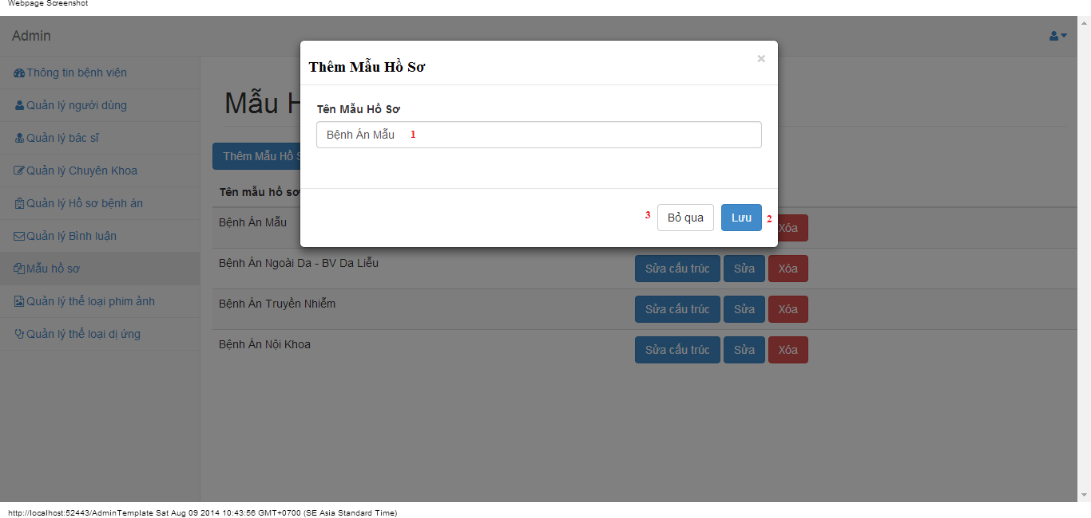

#### Objects and Actions

##### Data fields

|  |  |  |  |  |  |  |
| --- | --- | --- | --- | --- | --- | --- |
| **Field No** | **Field name** | **Type** | **Mandatory** | **Data type** | **Max length** | **Description** |
| 1 | Tên mẫu hồ sơ | Textbox | Yes | String | 50 | Contain name medical profile |

##### Actions

|  |  |  |  |  |  |
| --- | --- | --- | --- | --- | --- |
| **Field No** | **Field name** | **Type** | **Action** | **Description** | **Validation** |
| 9 | Lưu | Button | On click | Submit inputted data to server | Inputted data must be valid |
| 10 | Bỏ qua | Button | On click | Dismiss popup |  |

### Editor/update medical profile templates screen

#### Screen image

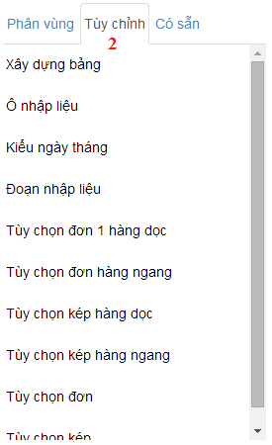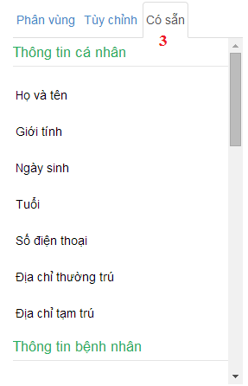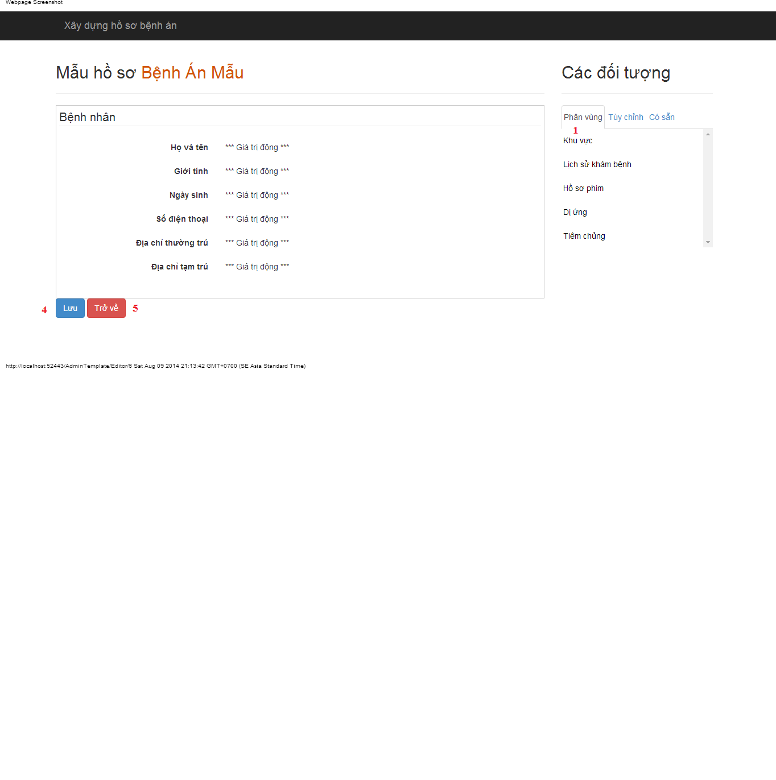

#### Objects and Actions

##### Actions

|  |  |  |  |  |  |
| --- | --- | --- | --- | --- | --- |
| **Field No** | **Field name** | **Type** | **Action** | **Description** | **Validation** |
| 1 | Phân vùng | Link | On click | Drag data to create/update medical profile template |  |
| 2 | Tùy chỉnh | Link | On click | Dismiss popup |  |
| 3 | Có sẵn | Link | On click | Drag data to create/update medical profile template |  |
| 4 | Lưu | Button | On click | Submit inputted data to server |  |
| 5 | Trở về | Button | On click | Back to previous page |  |

### Change password screen

#### Screen image



#### Objects and Actions

##### Data fields

|  |  |  |  |  |  |  |
| --- | --- | --- | --- | --- | --- | --- |
| **Field No** | **Field name** | **Type** | **Mandatory** | **Data type** | **Max length** | **Description** |
| 1 | Mật khẩu hiện tại | Textbox | Yes | String | 50 | Contain user’s password |
| 2 | Mật khẩu mới | Textbox | Yes | String | 50 | Contain user’s new password |
| 3 | Xác nhận mật khẩu | Textbox | Yes | String | 50 | Contain user’s re-password |

##### Actions

|  |  |  |  |  |  |
| --- | --- | --- | --- | --- | --- |
| **Field No** | **Field name** | **Type** | **Action** | **Description** | **Validation** |
| 9 | Cập nhật mật khẩu | Button | On click | Submit inputted data to server | Inputted data must be valid |
| 10 | Bỏ qua | Button | On click | Dismiss popup |  |

### Manage patient screen

#### Screen image

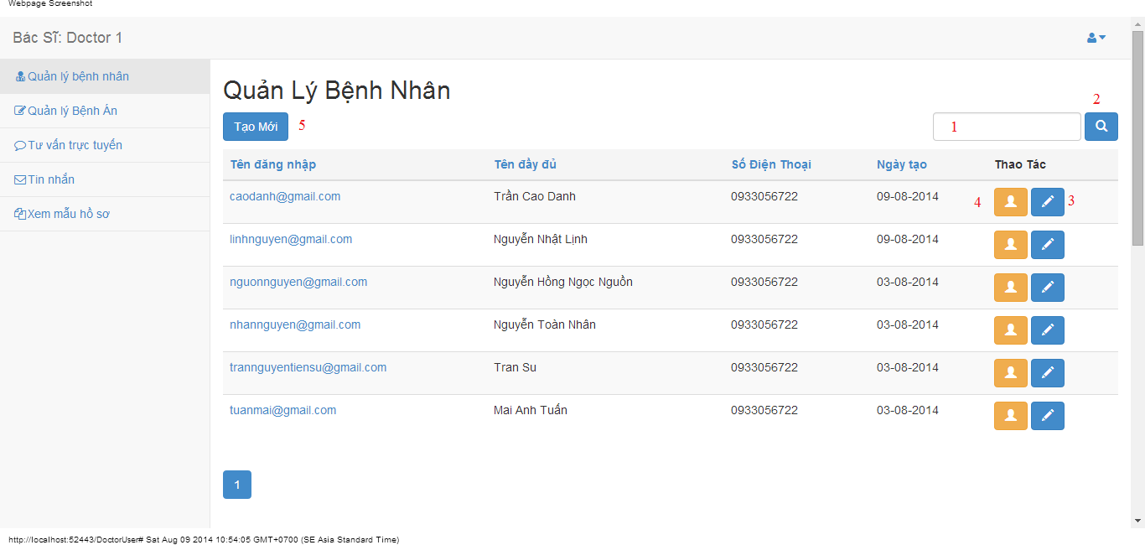

#### Objects and Actions

##### Data fields

|  |  |  |  |  |  |  |
| --- | --- | --- | --- | --- | --- | --- |
| **Field No** | **Field name** | **Type** | **Mandatory** | **Data type** | **Max length** | **Description** |
| 1 | Search | Textbox | No | String | 50 | Contain search condition to find some user account |

##### Actions

|  |  |  |  |  |  |
| --- | --- | --- | --- | --- | --- |
| **Field No** | **Field name** | **Type** | **Action** | **Description** | **Validation** |
| 2 | Tìm | Button | On click | Send inputted search condition to server |  |
| 3 | Cập nhật | Button | On click | Forward to popup “Edit” |  |
| 4 | Xem chi tiết | Link | On click | Forward to popup “View” |  |
| 5 | Tạo mới | Button | On click | Forward to popup “Create” |  |

### Create/edit patient screen

#### Screen image

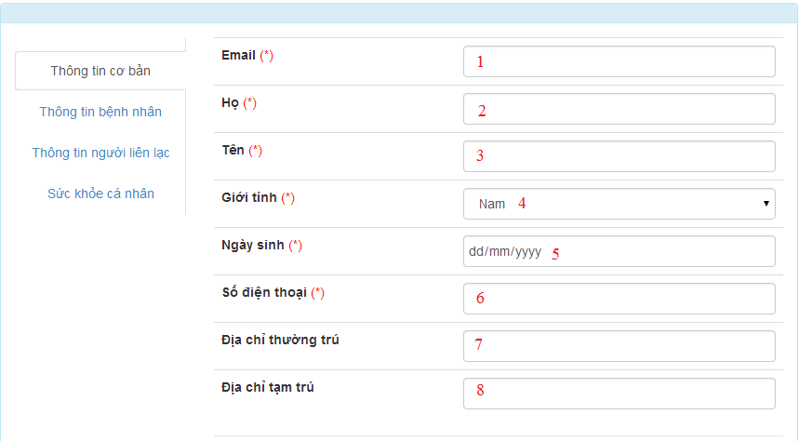









#### Objects and Actions

##### Data fields

|  |  |  |  |  |  |  |
| --- | --- | --- | --- | --- | --- | --- |
| **Field No** | **Field name** | **Type** | **Mandatory** | **Data type** | **Max length** | **Description** |
| 1 | Email | Textbox | Yes | String | 50 | Contain user’s email |
| 2 | Họ | Textbox | Yes | String | 50 | Contain user’s last name |
| 3 | Tên | Textbox | Yes | String | 50 | Contain user’s first name |
| 4 | Giới tính | Textbox | Yes | String |  | Contain user’s gender |
| 5 | Ngày sinh | Textbox | Yes | Date |  | Contain user’s birthday |
| 6 | Số điện thoại | Textbox | Yes | String | 12 | Contain user’s phone |
| 7 | Địa chỉ thường trú | Textbox | Yes | String | 50 | Contain user’s primary address |
| 8 | Địa chỉ tạm trú | Textbox | No | String | 50 | Contain user’s secondary address |
| 9 | Dân tộc | DDL | No | String | 50 | Contain user’s ethnicity |
| 10 | Quốc tịch | DDL | No | String | 50 | Contain user’s nationality |
| 11 | Công việc | Textbox | No | String | 50 | Contain user’s job |
| 12 | Nơi làm việc | Textbox | No | String | 50 | Contain user’s where to work |
| 13 | Mã số thẻ bảo hiểm y tế | Textbox | No | String | 50 | Contain user’s health insurance id |
| 14 | Ngày cấp | Textbox | No | Date | 50 | Contain user’s health insurance issued |
| 15 | Ngày hết hạn | Textbox | No | Date | 50 | Contain user’s health insurance date expired |
| 16 | Người liên lạc | Textbox | No | String | 50 | Contain user’s contact person |
| 17 | Địa chỉ người liện lạc | Textbox | No | String | 50 | Contain user’s contact person address |
| 18 | Số điện thoại người liên lạc | Textbox | No | String | 50 | Contain user’s contact person phone |
| 19 | Chiều cao | Textbox | No | String | 50 | Contain user’s height |
| 20 | Cân nặng | Textbox | No | String | 50 | Contain user’s weight |
| 21 | Màu mắt | Textbox | No | String | 50 | Contain user’s eye color |
| 22 | Màu tóc | Textbox | No | String | 50 | Contain user’s hair color |
| 23 | Nhóm máu | Textbox | No | String | 50 | Contain user’s blood type |
| 24 | Lượng đồ uống có cồn hàng tuần | Textbox | No | String | 50 | Contain user’s alcohol per week |
| 25 | Số năm uống | Textbox | No | String | 50 | Contain user’s alcohol number of year |
| 26 | Lượng thuốc hút hàng tuần | Textbox | No | String | 50 | Contain user’s smoke per week |
| 27 | Số năm hút | Textbox | No | String | 50 | Contain user’s smoke number of year |
| 28 | Tên loại thể thao | Textbox | No | String | 50 | Contain user’s sport name |
| 29 | Thời lượng tham gia hằng tuần | Textbox | No | String | 50 | Contain user’s sport per week |
| 30 | Tham gia khác | Textbox | No | String | 50 | Contain user’s exercise type |
| 31 | Thời lượng tham gia hằng tuần | Textbox | No | String | 50 | Contain user’s exercise per week |

##### Actions

|  |  |  |  |  |  |
| --- | --- | --- | --- | --- | --- |
| **Field No** | **Field name** | **Type** | **Action** | **Description** | **Validation** |
| 32 | Lưu | Button | On click | Submit inputted data to server | Inputted data must be valid |
| 33 | Bỏ qua | Button | On click | Dismiss model |  |

### View patient screen

#### Screen image

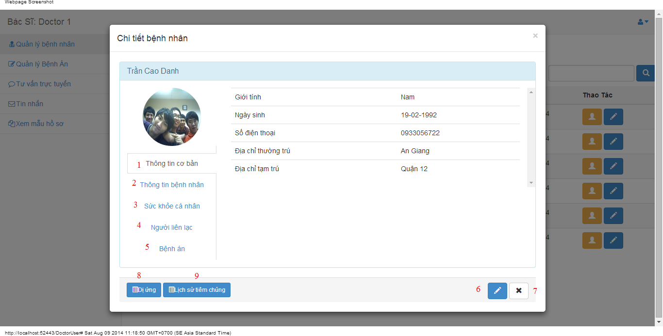

#### Objects and Actions

##### Actions

|  |  |  |  |  |  |
| --- | --- | --- | --- | --- | --- |
| **Field No** | **Field name** | **Type** | **Action** | **Description** | **Validation** |
| 1 | Thông tin cơ bản | Link | On click | Contain user’s basic information. |  |
| 2 | Thông tin bệnh nhân | Link | On click | Contain patient’s information. |  |
| 3 | Sức khỏe cá nhân | Link | On click | Contain user’s health record |  |
| 4 | Người liên lạc | Link | On click | Contain user’s contact person information |  |
| 5 | Bệnh án | Link | On click | Add/Edit medical profile for patient |  |
| 6 | Cập nhật | Button | On click | Forward to popup “EditPatient” |  |
| 7 | Bỏ qua | Button | On click | Dismiss modal |  |
| 8 | Dị ứng | Button | On click | Forward to popup “Allergy” |  |
| 9 | Lịch sử tiêm chủng | Button | On click | Forward to popup “Immunization” |  |

### Doctor comment screen

#### Screen image

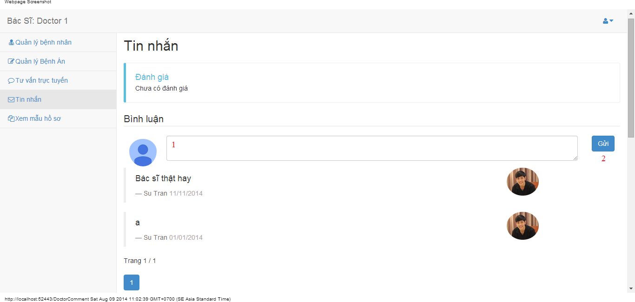

#### Objects and Actions

##### Data fields

|  |  |  |  |  |  |  |
| --- | --- | --- | --- | --- | --- | --- |
| **Field No** | **Field name** | **Type** | **Mandatory** | **Data type** | **Max length** | **Description** |
| 1 | Bình luận | Textbox | No | String |  | Comment of doctor |

##### Actions

|  |  |  |  |  |  |
| --- | --- | --- | --- | --- | --- |
| **Field No** | **Field name** | **Type** | **Action** | **Description** | **Validation** |
| 2 | Gửi | Button | On click | Summit inputted data to server |  |

### Doctor conversation screen

#### Screen image

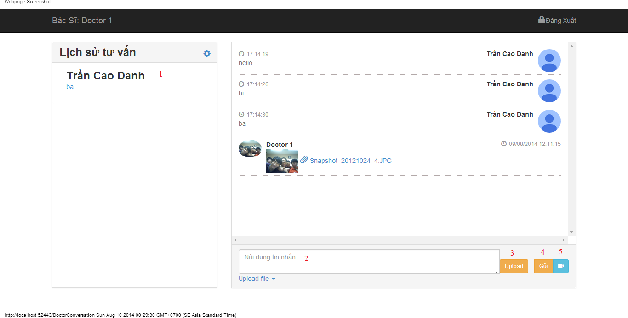

#### Objects and Actions

##### Data fields

|  |  |  |  |  |  |  |
| --- | --- | --- | --- | --- | --- | --- |
| **Field No** | **Field name** | **Type** | **Mandatory** | **Data type** | **Max length** | **Description** |
| 2 | Nội dung tin nhắn | Textbox | No | String |  | Contain user’s content conversation |

##### Actions

|  |  |  |  |  |  |
| --- | --- | --- | --- | --- | --- |
| **Field No** | **Field name** | **Type** | **Action** | **Description** | **Validation** |
| 1 | Lịch sử tư vấn | Link | On click | Click on a patient to chat |  |
| 3 | Upload | File | On click | Submit inputted file to server |  |
| 4 | Gửi | Button | On click | Submit inputted data to server |  |
| 5 | Yêu cầu xem webcam | Button | On click | Request webcam to patient |  |

### Doctor information screen

#### Screen image

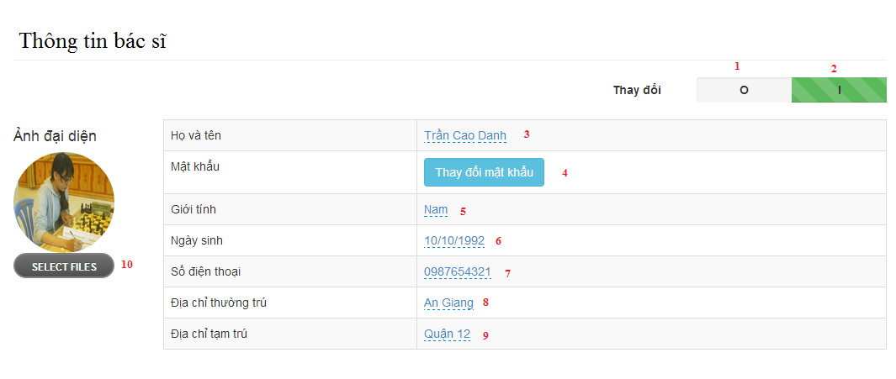

#### Objects and Actions

##### Data fields

|  |  |  |  |  |  |  |
| --- | --- | --- | --- | --- | --- | --- |
| **Field No** | **Field name** | **Type** | **Mandatory** | **Data type** | **Max length** | **Description** |
| 3 | Họ và tên | Textbox | Yes | String | 50 | Contain user’s full name |
| 5 | Giới tính | List | Yes | String | 50 | Contain user’s gender |
| 6 | Ngày sinh | Textbox | Yes | Date | 12 | Contain user’s birthday |
| 7 | Số điện thoại | Textbox | Yes | String | 12 | Contain user’s phone |
| 8 | Địa chỉ thường trú | Textbox | Yes | String | 50 | Contain user’s primary address |
| 9 | Địa chỉ tạm trú | Textbox | No | String | 50 | Contain user’s secondary address |

##### Actions

|  |  |  |  |  |  |
| --- | --- | --- | --- | --- | --- |
| **Field No** | **Field name** | **Type** | **Action** | **Description** | **Validation** |
| 1 | 0 | Checkbox | On click | Click “0” to view table admin information |  |
| 2 | I | Checkbox | On click | Click “I” to edit table data admin information |  |
| 4 | Thay đổi mật khẩu | Button | On click | Forward to popup “ChangePassword” |  |
| 10 | Chọn tệp | File | On click | Submit inputted file to server |  |

### Patient information screen

#### Screen image

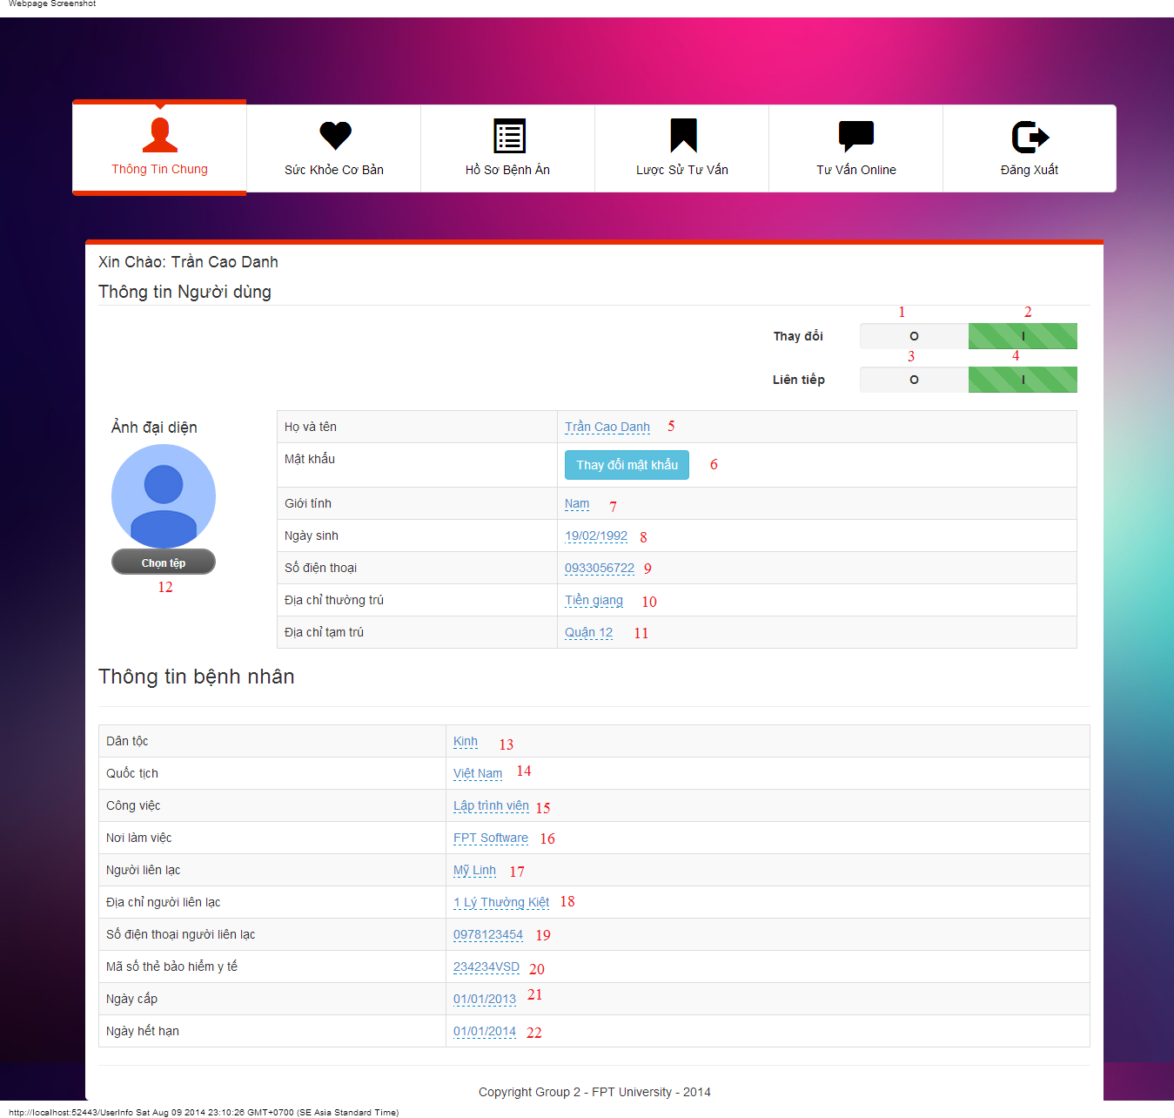

#### Objects and Actions

##### Data fields

|  |  |  |  |  |  |  |
| --- | --- | --- | --- | --- | --- | --- |
| **Field No** | **Field name** | **Type** | **Mandatory** | **Data type** | **Max length** | **Description** |
| 5 | Họ Tên | Textbox | Yes | String | 50 | Contain user’s full name |
| 7 | Giới tính | Textbox | Yes | String |  | Contain user’s gender |
| 8 | Ngày sinh | Textbox | Yes | Date |  | Contain user’s birthday |
| 9 | Số điện thoại | Textbox | Yes | String | 12 | Contain user’s phone |
| 10 | Địa chỉ thường trú | Textbox | Yes | String | 50 | Contain user’s primary address |
| 11 | Địa chỉ tạm trú | Textbox | No | String | 50 | Contain user’s secondary address |
| 12 | Dân tộc | DDL | No | String | 50 | Contain user’s ethnicity |
| 13 | Quốc tịch | DDL | No | String | 50 | Contain user’s nationality |
| 14 | Công việc | Textbox | No | String | 50 | Contain user’s job |
| 15 | Nơi làm việc | Textbox | No | String | 50 | Contain user’s where to work |
| 20 | Mã số thẻ bảo hiểm y tế | Textbox | No | String | 50 | Contain user’s health insurance id |
| 21 | Ngày cấp | Textbox | No | Date | 50 | Contain user’s health insurance issued |
| 22 | Ngày hết hạn | Textbox | No | Date | 50 | Contain user’s health insurance date expired |
| 18 | Người liên lạc | Textbox | No | String | 50 | Contain user’s contact person |
| 19 | Địa chỉ người liện lạc | Textbox | No | String | 50 | Contain user’s contact person address |
| 20 | Số điện thoại người liên lạc | Textbox | No | String | 50 | Contain user’s contact person phone |

##### Actions

|  |  |  |  |  |  |
| --- | --- | --- | --- | --- | --- |
| **Field No** | **Field name** | **Type** | **Action** | **Description** | **Validation** |
| 1 | 0 | Checkbox | On click | Click “0” to view table admin information |  |
| 2 | I | Checkbox | On click | Click “I” to edit table data admin information |  |
| 3 | O | Checkbox | On click | Click “0” to not next value after 300 second |  |
| 4 | I | Checkbox | On click | Click “0” to next value after 300 second |  |
| 6 | Thay đổi mật khẩu | Button | On click | Forward to popup “ChangePassword” |  |
| 12 | Chọn tệp | File | On click | Submit inputted file to server |  |

### Patient health record screen

#### Screen image

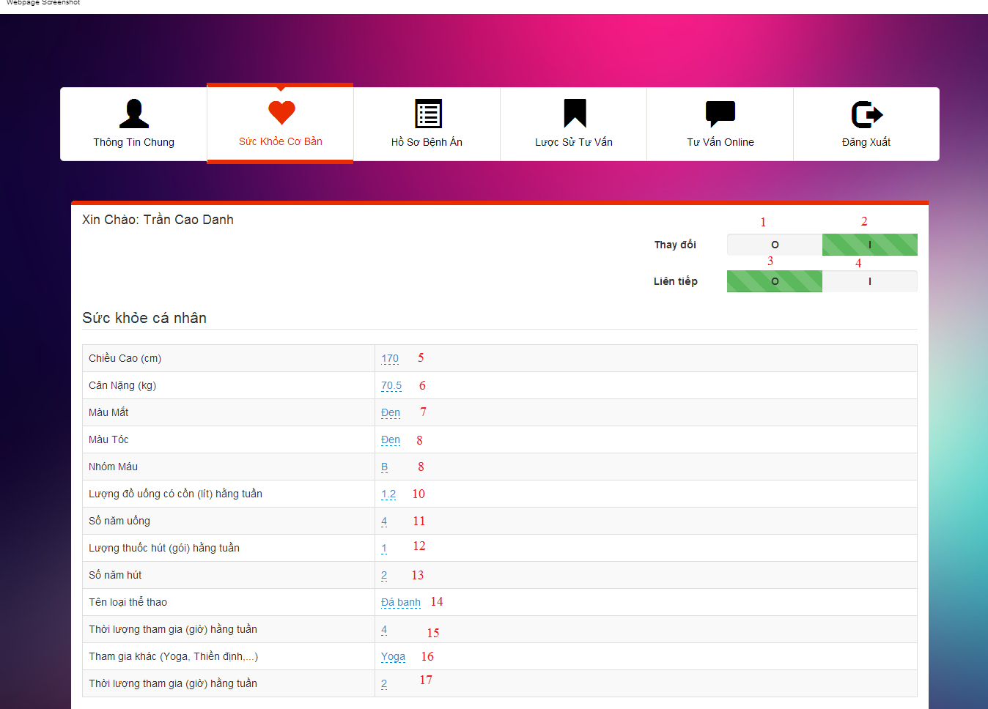

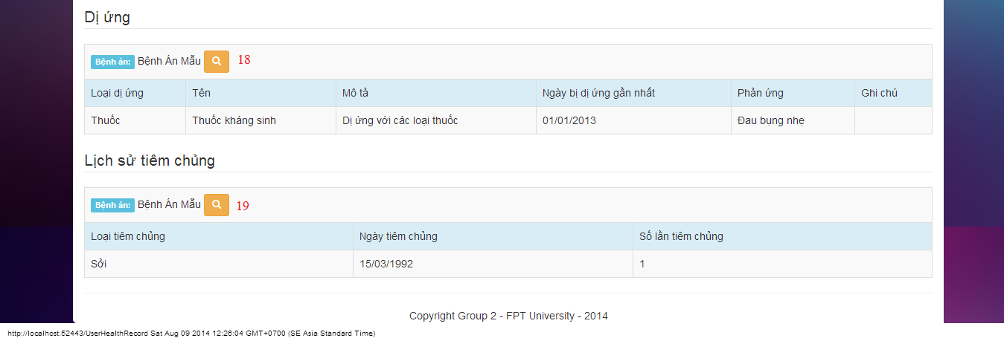

#### Objects and Actions

##### Data fields

|  |  |  |  |  |  |  |
| --- | --- | --- | --- | --- | --- | --- |
| **Field No** | **Field name** | **Type** | **Mandatory** | **Data type** | **Max length** | **Description** |
| 5 | Chiều cao | Textbox | No | String | 50 | Contain user’s height |
| 6 | Cân nặng | Textbox | No | String | 50 | Contain user’s weight |
| 7 | Màu mắt | Textbox | No | String | 50 | Contain user’s eye color |
| 8 | Màu tóc | Textbox | No | String | 50 | Contain user’s hair color |
| 9 | Nhóm máu | Textbox | No | String | 50 | Contain user’s blood type |
| 10 | Lượng đồ uống có cồn hàng tuần | Textbox | No | String | 50 | Contain user’s alcohol per week |
| 11 | Số năm uống | Textbox | No | String | 50 | Contain user’s alcohol number of year |
| 12 | Lượng thuốc hút hàng tuần | Textbox | No | String | 50 | Contain user’s smoke per week |
| 13 | Số năm hút | Textbox | No | String | 50 | Contain user’s smoke number of year |
| 14 | Tên loại thể thao | Textbox | No | String | 50 | Contain user’s sport name |
| 15 | Thời lượng tham gia hằng tuần | Textbox | No | String | 50 | Contain user’s sport per week |
| 16 | Tham gia khác | Textbox | No | String | 50 | Contain user’s exercise type |
| 17 | Thời lượng tham gia hằng tuần | Textbox | No | String | 50 | Contain user’s exercise per week |

##### Actions

|  |  |  |  |  |  |
| --- | --- | --- | --- | --- | --- |
| **Field No** | **Field name** | **Type** | **Action** | **Description** | **Validation** |
| 1 | 0 | Checkbox | On click | Click “0” to view table admin information |  |
| 2 | I | Checkbox | On click | Click “I” to edit table data admin information |  |
| 3 | O | Checkbox | On click | Click “0” to not next value after 300 second |  |
| 4 | I | Checkbox | On click | Click “0” to next value after 300 second |  |
| 18 | Bệnh án mẫu | Button | On click | Forward to “Details” medical profile page |  |
| 19 | Bệnh án mẫu | Button | On click | Forward to “Details” medical profile page |  |

### User conversation screen

#### Screen image

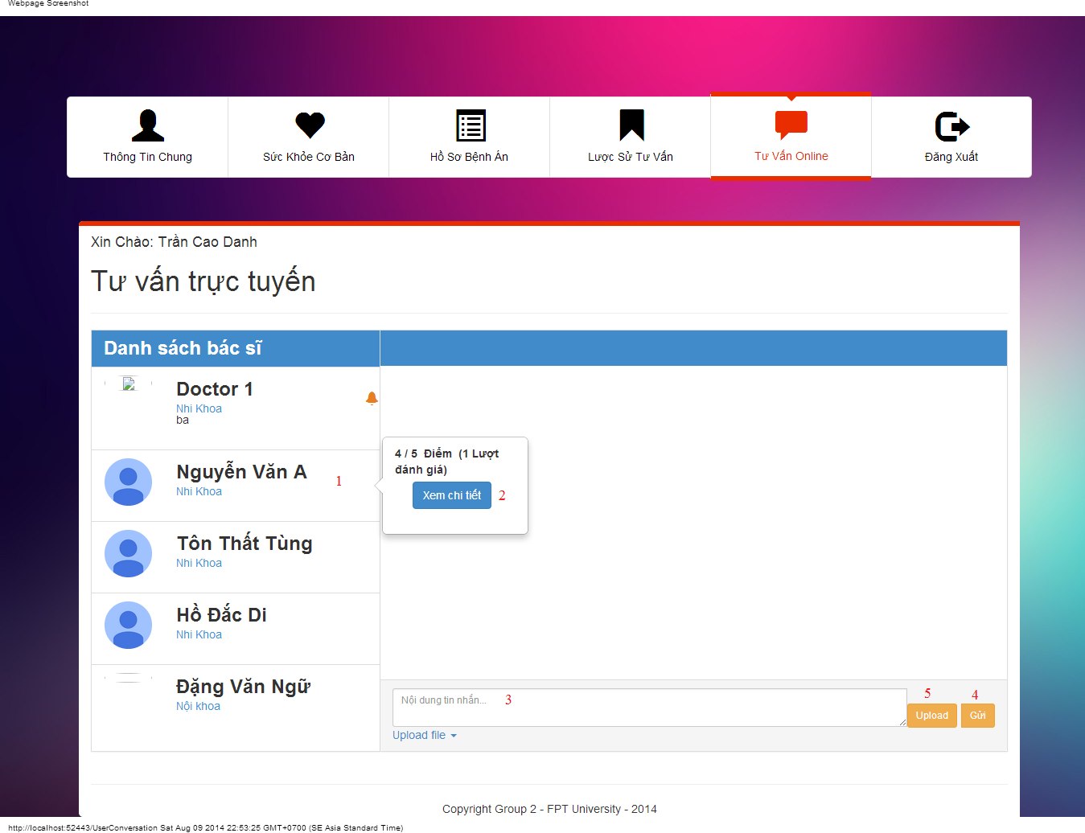

#### Objects and Actions

##### Data fields

|  |  |  |  |  |  |  |
| --- | --- | --- | --- | --- | --- | --- |
| **Field No** | **Field name** | **Type** | **Mandatory** | **Data type** | **Max length** | **Description** |
| 3 | Nội dung tin nhắn | Textbox | No | String |  | Contain user’s content conversation |

##### Actions

|  |  |  |  |  |  |
| --- | --- | --- | --- | --- | --- |
| **Field No** | **Field name** | **Type** | **Action** | **Description** | **Validation** |
| 1 | Danh sách bác sĩ | Link | On click | Click on a doctor to chat |  |
| 2 | Xem chi tiết | Button | On click | Forward to “Comment” page |  |
| 4 | Gửi | Button | On click | Submit inputted data to server |  |
| 5 | Upload | File | On click | Submit inputted file to server |  |

### User comment/rating screen

#### Screen image

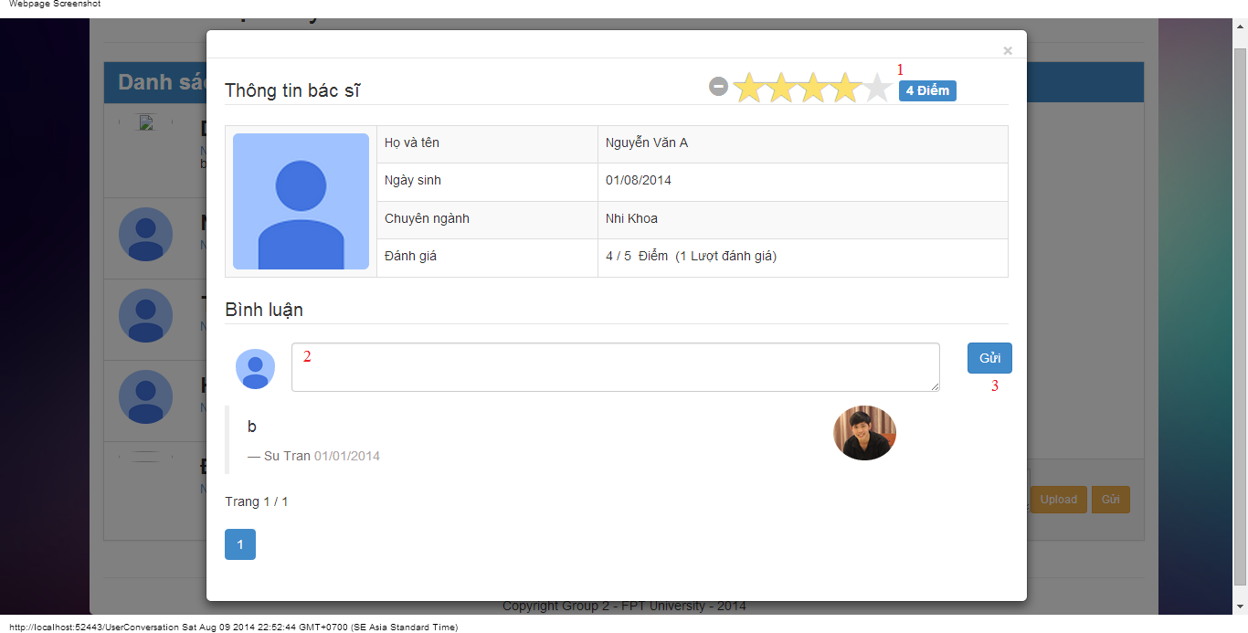

#### Objects and Actions

##### Data fields

|  |  |  |  |  |  |  |
| --- | --- | --- | --- | --- | --- | --- |
| **Field No** | **Field name** | **Type** | **Mandatory** | **Data type** | **Max length** | **Description** |
| 2 | Bình luận | Textbox | No | String |  | Comment of user |

##### Actions

|  |  |  |  |  |  |
| --- | --- | --- | --- | --- | --- |
| **Field No** | **Field name** | **Type** | **Action** | **Description** | **Validation** |
| 1 | Điểm | Button | On click | Summit inputted rate to server |  |
| 3 | Gửi | Button | On click | Summit inputted data to server |  |

## 

## Database Design



Figure Database Relationship Design

# System Implementation & Test (SIT)

## Introduction

### System Overview

The system is implemented using MVC architecture and comprises of three parts. The first one is used by the hospital admin to build medical profile templates, manage users. Second part is used by doctors to create medical profile for patients, update patient’s information. The last one is for patients to view their medical profiles, update information, get consulted.

### Test Approach

Testing approach defines the scope and goals of testing phase. It describes the strategy for the test, what will be test and what will not, the method used for testing and how much resources are required to perform the test.

Method: System Testing, Black-box Testing.

## Performance measures

### Assumptions

#### Software and Hardware

* CPU: Core i3 2.13Ghz
* Network connection: 72.0 Mbps
* Hard Drive: 320GB
* Memory: 4096MB RAM
* Version of Operation System: Windows 7 Professional 64-bit
* Version of Software:
  + Web Server: IIS Express 8.0.8418.0
  + Database: SQL Server 2008 R2

#### Performance requirement

|  |  |
| --- | --- |
| Metric | Value |
| Average Page Load Time | < 4 sec |
| Max Page Load Time | < 60 sec |
| Minimum Throughput | Per scenario |
| Max Number of Registered Users | 2000k |
| Max Records in the Database | 4000k |
| Max Database Size | 2GB |

Figure 2.1.2. Performance Requirement

### Scenarios Frequency (Throughput per scenario)

|  |  |  |  |  |  |
| --- | --- | --- | --- | --- | --- |
| Scenario (Thread Group) | Expected Normal Throughput in peaks [scenarios/sec] (100%, Load Test) | Number of concurrent threads (100%) | Throughput in JMeter plan  [scenarios/sec] (100%, Load Test) | Number of concurrent threads (200%) | Throughput in JMeter plan  [scenarios/sec] (200%, Stress Test) |
| Anonymous views 3 pages | 50 | 200 | 23.0 | 400 | 24.1 |
| Admin views 7 pages | 100 | 3 | 0.74 | 200 | 0.803 |
| Doctor views 5 pages | 120 | 30 | 5.33 | 240 | 5.7 |
| Patient views 5 pages | 120 | 100 | 18.0 | 240 | 19.3 |
| All | 150 | 390 | 44.7 | 780 | 46.79 |

Figure Scenarios Frequency

## Test Plan

### Features to be tested

#### <User> Login

#### <User> Logout

#### <User> Register

#### <User> Remember me

#### <User> Forget password

#### <Patient> Edit patient information

#### <Patient> Edit health record

#### <Patient> View medical profile

#### <Patient> Chatting

#### <Patient> Attach files

#### <Doctor> List patients

#### <Doctor> Add patient

#### <Doctor> Edit patient

#### <Doctor> View patient

#### <Doctor> List medical profiles

#### <Doctor> Edit medical profile

#### <Doctor> Doctor chatting

#### <Doctor> Request webcam

#### <Doctor> View medical profile structure

#### <Admin> List doctors

#### <Admin> Add doctor

#### <Admin> Edit doctor

#### <Admin> List medical profile template

#### <Admin> Add new medical profile template

#### <Admin> Edit medical profile template

### Features not to be tested

#### <User> Homepage’s navigation

#### <User> 404 page

#### <User> Access Denied page

#### <Admin> Edit hospital information

#### <Admin> List patients

#### <Admin> Add patient

#### <Admin> Edit patient

#### <Admin> List specialty fields

#### <Admin> Edit specialty field

#### <Admin> Add specialty field

#### <Admin> List film types

#### <Admin> Add film type

#### <Admin> Edit film type

#### <Admin> List allergy type

#### <Admin> Add allergy type

#### <Admin> Edit allergy type

### Testing Tools and Environment

* IIS Express Server (this server comes with Visual Studio 2012)
* Google Chrome 36.0
* Mozilla Firefox 30.0

## 

## Test cases

### <User> Login

#### Purpose

#### Inputs

|  |  |  |
| --- | --- | --- |
| Username | Password | Role |
| Admin | 123456 | Admin |
| Doctor1 | 123456 | Doctor |
| Sutran | 123456 | User |

|  |  |  |  |  |  |  |  |
| --- | --- | --- | --- | --- | --- | --- | --- |
| ID | Test Case Description | Pre-Conditions | Test Case Procedure | Expected Output | Result | Test Date | Note |
| <User> Login. | | | | | | | |
| Steps 1. Go to Home index page  2. Click on “Đăng Nhập” anchor link | | | | | | | |
| [UL-01] | Test Login Page |  | Go to website homepage.  Click on “Đăng Nhập” link | [Login] page is displayed. The content includes:  Email (textbox)  Password (textbox)  “Đăng Nhập” button | Pass | 07/24/2014 | SuTNT |
| [UL-02] | Test Login Validation Blank Field | User stayed at “Login” Page. | Go to [Login] page.  Don’t input information.  Click on “Đăng Nhập” button | Error message will be displayed: | Pass | 07/24/2014 | SuTNT |
| [UL-03] | Test Login As Admin Role Successfully | User stayed at “Login” Page. | Go to [Login] page  Input “admin” for username field.  Input “123456” for password field.  Click on “Đăng Nhập” button. | Login successfully.  [Admin Home] page will be shown. | Pass | 07/24/2014 | SuTNT |
| [UL-04] | Test Login As Doctor Successfully | User stayed at “Login” Page. | Go to [Login] page  Input “doctor1” for username field.  Input “123456” for password field.  Click on “Đăng Nhập” button. | Login successfully.  [Doctor] page will be shown. | Pass | 07/24/2014 | SuTNT |
| [UL-05] | Test Login As Patient Successfully | User stayed at “Login” Page. | Go to [Login] page  Input “sutran” for username field.  Input “123456” for password field.  Click on “Đăng Nhập” button. | Login successfully.  [Patient] page will be shown. | Pass | 07/24/2014 | SuTNT |
| [UL-06] | Test Login with wrong email | User stayed at “Login” Page. | Go to [Login] page.  Input “xvdsf” for email field.  Input “123456” for password field.  Click on “Đăng Nhập” button. | Error message will be displayed:  “Email hoặc mật khẩu không đúng.” | Pass | 07/24/2014 | SuTNT |
| [UL-07] | Test Login with wrong password | User stayed at “Login” Page. | Go to [Login] page.  Input “sutran@gmail.com” for username field.  Input “asd123” for password field.  Click on “Đăng Nhập” button. | Error message will be displayed:  “Email hoặc mật khẩu không đúng.” | Pass | 07/24/2014 | SuTNT |

### <User> Logout

Reference to CD: <Root of CD>\Reports\Report 5 - Group 2.docx

### <User> Register

|  |  |  |  |  |  |  |  |
| --- | --- | --- | --- | --- | --- | --- | --- |
| ID | Test Case Description | Pre-Conditions | Test Case Procedure | Expected Output | Result | Test Date | Note |
| <User> Register. | | | | | | | |
| Steps 1. Go to Home index page  2. Click on “Đăng Kí” anchor link | | | | | | | |
| [UR-01] | Test Register Page | User stayed at “Register” Page. | Go to website homepage.  Click on “Đăng kí” link | [Register] page is displayed. The content includes:  Email (textbox)  Lastname (textbox)  Firstname (textbox)  Password (textbox)  Re-Password (textbox)  Captcha (ReCaptcha)  “Đăng Kí” button | Pass | 07/28/2014 | DanhTC |
| [UR-02] | Test Register Validation Blank Field | User stayed at “Register” Page. | Go to [Register] page.  Don’t input information.  Click on “Đăng kí” button | Error message will be displayed:  “Bạn cần nhập giá trị này” | Pass | 07/28/2014 | DanhTC |
| [UR-03] | Test Register Validation with Email existed | User stayed at “Register” Page. | Go to [Register] page.  Input email exsited.  Click on “Đăng kí” button | Error message will be displayed:  “Địa chỉ email đã được đăng kí” | Pass | 07/28/2014 | DanhTC |
| [UR-04] | Test Register Validation with Lastname and Firstname maximum 50 characters | User stayed at “Register” Page. | Go to [Register] page.  Input lastname and firstname over 50 characters.  Click on “Đăng kí” button | Error message will be displayed:  “Độ dài không được quá 50 ký tự” | Pass | 07/28/2014 | DanhTC |
| [UR-05] | Test Register Validation with Password and Re-Password maximum 32 characters and minimum 6 characters | User stayed at “Register” Page. | Go to [Register] page  Input Password and Re-Password over 32 characters or less than 6 characters. | Error message will be displayed:  “Độ dài trong khoảng 6 đến 32 ký tự” | Pass | 07/28/2014 | DanhTC |
| [UR-06] | Test Register Validation with Re-Password not match Password | User stayed at “Register” Page. | Go to [Register] page  Input Re-Password dont match Password. | Error message will be displayed:  “Xác nhận mật khẩu không trùng khớp” | Pass | 07/28/2014 | DanhTC |
| [UR-07] | Test Register Validation with don’t input recaptcha | User stayed at “Register” Page. | Go to [Register] page  Don’t input recaptcha. | Error message will be displayed:  “Mã captcha không được để trống” | Pass | 07/28/2014 | DanhTC |
| [UR-08] | Test Register Validation with input not match recaptcha | User stayed at “Register” Page. | Go to [Register] page  Input recaptcha not match. | Error message will be displayed:  “Mã captcha không trùng khớp” | Pass | 07/28/2014 | DanhTC |
| [UR-09] | Test Register successfully | User stayed at “Register” Page. | Go to [Register] page.  Input:  “danhtran@yahoo.com” for email field.  “Trần” for lastname field.  “Danh” for firstname field.  “123456” for password field.  “123456” for re-password field.  “204” for recaptcha  Click on “Đăng Kí” button. | Return to index homepage | Pass | 07/28/2014 | DanhTC |
| [UR - 10] | Test system to send mail to announce change password successfully. | Register successfully. | Go to email is registered and check inbox new mail to see mail announce successfully. | Content mail:  “Chào mừng bạn đến với OMCS - Hệ thống tư vấn y khoa trực tuyến  Vui lòng nhấn vào đường dẫn bên dưới để kích hoạt” | Pass | 07/28/2014 | DanhTC |

### <User> Remember me

Reference to CD: <Root of CD>\Reports\Report 5 - Group 2.docx

### <User> Forget password

Reference to CD: <Root of CD>\Reports\Report 5 - Group 2.docx

### <Patient> Edit patient information

Reference to CD: <Root of CD>\Reports\Report 5 - Group 2.docx

### <Patient> Edit health record

#### Purpose

#### Inputs

|  |  |  |
| --- | --- | --- |
| Email | Password | Role |
| trannguyentiensu@gmail.com | 123456 | User |

|  |  |  |  |  |  |  |  |
| --- | --- | --- | --- | --- | --- | --- | --- |
| ID | Test Case Description | Pre-Conditions | Test Case Procedure | Expected Output | Result | Test Date | Note |
| <Patient> Edit health record. | | | | | | | |
| Steps 1. Go to Home index page  2. Click on “Đăng Nhập” anchor link  3. Input email and password correct  3. Click on “Sức Khỏe Cá Nhân” tab in navigation. | | | | | | | |
| [PEH-01] | Test UserHealthRecord Page | Login successfully with role “Patient” | Click on “Sức Khỏe Cá Nhân” tab in navigation. | UserInfo page is displayed. The content includes table and two fieldset:  “Sức khỏe cá nhân” table with values is created:  + Chiều Cao (cm): …………..  + Cân nặng (kg): ……………  + Màu tóc: ……………  + Màu mắt: …………  + Nhóm máu: ……………  + Lượng đồ uống có cồn (lít) hàng tuần: ……………  + Số năm uống: ……………  + Lượng thuốc hút (gói) hằng tuần: ……………  + Số năm hút: ……………  + Tên loại thể thao: ……………  + Thời gian tham gia (giờ) hằng tuần: ……………  + Tham gia khác (Yoga, Thiền định, ….): ……………  + Thời gian tham gia (giờ) hằng tuần: ……………  “Dị ứng” and “Lịch sử tiêm chủng” fieldsets. | Pass | 07/28/2014 | DanhTC |
| [PEH-02] | Test “Thay đổi” button | Login successfully with role “Patient”.  User stayed at “UserHealthRecord” Page. | Click “Bật” on “Thay đổi” | The content includes table with fields to user edit:  + Chiều Cao (cm): …………..  + Cân nặng (kg): ……………  + Màu tóc: ……………  + Màu mắt: …………  + Nhóm máu: ……………  + Lượng đồ uống có cồn (lít) hàng tuần: ……………  + Số năm uống: ……………  + Lượng thuốc hút (gói) hằng tuần: ……………  + Số năm hút: ……………  + Tên loại thể thao: ……………  + Thời gian tham gia (giờ) hằng tuần: ……………  + Tham gia khác (Yoga, Thiền định, ….): ……………  + Thời gian tham gia (giờ) hằng tuần: …………… | Pass | 07/28/2014 | DanhTC |
| [PEH-03] | Test fields to edit Validation Blank Field | Login successfully with role “Patient”.  User stayed at “UserHealthRecord” Page.  Click “Bật” on “Thay đổi” button. | Don’t input information.  Click on “√” button. | Error message will be displayed:  “Bạn cần nhập giá trị này” | Pass | 07/28/2014 | DanhTC |
| [PEH -04] | Test “Chiều Cao (cm)”, “Cân nặng (kg)”, “Lượng đồ uống có cồn (lít) hàng tuần”, “Số năm uống”, “Lượng thuốc hút (gói) hằng tuần”, “Số năm hút”, “Thời gian tham gia (giờ) hằng tuần”, “Thời gian tham gia (giờ)” fields to edit Validation must be numbers | Login successfully with role “Patient”.  User stayed at “UserHealthRecord” Page.  Click “Bật” on “Thay đổi” button. | Input “Chiều Cao (cm)”, “Cân nặng (kg)”, “Lượng đồ uống có cồn (lít) hàng tuần”, “Số năm uống”, “Lượng thuốc hút (gói) hằng tuần”, “Số năm hút”, “Thời gian tham gia (giờ) hằng tuần”, “Thời gian tham gia (giờ)” by characters.  Click on “√” button. | Error message will be displayed:  “Vui lòng nhập số!” | Pass | 07/28/2014 | DanhTC |
| [PE-05] | Test edit fields successfully | Login successfully with role “Patient”.  User stayed at “UserHealthRecord” Page.  Click “Bật” on “Thay đổi” button | Input fields such as:  + Chiều Cao (cm): 180  + Cân nặng (kg): 77  + Màu tóc: Đen  + Màu mắt: Đen  + Nhóm máu: B  + Lượng đồ uống có cồn (lít) hàng tuần: 0  + Số năm uống: 0  + Lượng thuốc hút (gói) hằng tuần: 0  + Số năm hút: 0  + Tên loại thể thao: Bóng đá  + Thời gian tham gia (giờ) hằng tuần: 5  + Tham gia khác (Yoga, Thiền định, ….): Không  + Thời gian tham gia (giờ) hằng tuần: 0  Click on “√” button. | + Chiều Cao (cm): 180  + Cân nặng (kg): 77  + Màu tóc: Đen  + Màu mắt: Đen  + Nhóm máu: B  + Lượng đồ uống có cồn (lít) hàng tuần: 0  + Số năm uống: 0  + Lượng thuốc hút (gói) hằng tuần: 0  + Số năm hút: 0  + Tên loại thể thao: Bóng đá  + Thời gian tham gia (giờ) hằng tuần: 5  + Tham gia khác (Yoga, Thiền định, ….): Không  + Thời gian tham gia (giờ) hằng tuần: 0 | Pass | 07/28/2014 | DanhTC |

### <Patient> View medical profile

Reference to CD: <Root of CD>\Reports\Report 5 - Group 2.docx

### <Patient> Chatting

Reference to CD: <Root of CD>\Reports\Report 5 - Group 2.docx

### <Patient> Attach files

Reference to CD: <Root of CD>\Reports\Report 5 - Group 2.docx

### <Doctor> List patients

Reference to CD: <Root of CD>\Reports\Report 5 - Group 2.docx

### <Doctor> Add patient

Reference to CD: <Root of CD>\Reports\Report 5 - Group 2.docx

### <Doctor> Edit patient

Reference to CD: <Root of CD>\Reports\Report 5 - Group 2.docx

### <Doctor> View patient

Reference to CD: <Root of CD>\Reports\Report 5 - Group 2.docx

### <Doctor> List medical profiles

Reference to CD: <Root of CD>\Reports\Report 5 - Group 2.docx

### <Doctor> Edit medical profile

#### Purpose

#### Inputs

|  |  |  |
| --- | --- | --- |
| Email | Password | Role |
| doctor1@gmail.com | 123456 | User |

|  |  |  |  |  |  |  |  |
| --- | --- | --- | --- | --- | --- | --- | --- |
| ID | Test Case Description | Pre-Conditions | Test Case Procedure | Expected Output | Result | Test Date | Note |
| <Doctor> Edit medical profiles. | | | | | | | |
| Steps 1. Go to Home index page  2. Click on “Đăng Nhập” anchor link  3. Input email and password correct  3. Click on “Quản lý bệnh án” tab.  4. Click on “Cập nhật” button. | | | | | | | |
| [DEM-01] | Test UpdateMedicalProfile Page | Login successfully with role “Doctor”.  User stayed at “DoctorMedicalProfile” Page. | Click on “Cập nhật” button. | Show medical profile is created by admin and doctor can edit medical profile to suitable with patients. | Pass | 07/28/2014 | DanhTC |
| [DLM-02] | Test “Cập nhật” button. | Login successfully with role “Doctor”.  User stayed at “DoctorMedicalProfile” Page.  Click on “Cập nhật” button. | Click on “Cập nhật” button. | “Cập nhật thành công” | Pass | 07/28/2014 | DanhTC |

### <Doctor> Doctor chatting

Reference to CD: <Root of CD>\Reports\Report 5 - Group 2.docx

### <Doctor> Request webcam

Reference to CD: <Root of CD>\Reports\Report 5 - Group 2.docx

### <Doctor> View medical profile structure

Reference to CD: <Root of CD>\Reports\Report 5 - Group 2.docx

### <Admin> List doctors

Reference to CD: <Root of CD>\Reports\Report 5 - Group 2.docx

### <Admin> Add doctor

Reference to CD: <Root of CD>\Reports\Report 5 - Group 2.docx

### <Admin> Edit doctor

Reference to CD: <Root of CD>\Reports\Report 5 - Group 2.docx

### <Admin> List medical profile template

Reference to CD: <Root of CD>\Reports\Report 5 - Group 2.docx

### <Admin> Add new medical profile template

Reference to CD: <Root of CD>\Reports\Report 5 - Group 2.docx

### <Admin> Edit medical profile template

Reference to CD: <Root of CD>\Reports\Report 5 - Group 2.docx

## Checklists

### Checklist of Layout

|  |  |  |  |  |
| --- | --- | --- | --- | --- |
| Questions | | Yes | No | N/A |
| 1 | Is the layout appear the same when using Chrome, Firefox and Internet Explorer 8 (or higher)? | X |  |  |
| 2 | Are all buttons have blue or green color? | X |  |  |
| 3 | Are all required fields have an asterisk to indicate they are required? | X |  |  |
| 4 | Can the text be read easily using a regular laptop? | X |  |  |
| 5 | Is form label stands still when validating message appears? | X |  |  |
| 6 | Should front-end layout stretched when browser is resized? |  | X |  |
| 7 | Should back-end layout stretched when browser is resized? | X |  |  |
| 8 | Does sidebar in back-end layout change when user navigate to another page? |  | X |  |
| 9 | Are all the fields prompts spelt correctly? | X |  |  |
| 10 | Is all user inputs captured in upper case or lower case consistently? | X |  |  |
| 11 | Are currency in the site in Vietnamese format | X |  |  |
| 12 | Are all messages in the system translated to Vietnamese | X |  |  |

#### Checklist of Authorization

|  |  |  |  |  |
| --- | --- | --- | --- | --- |
| Questions | | Yes | No | N/A |
| 1 | Does error message appears when user is redirected from a zone that required login? | X |  |  |
| 2 | Is the user required to fix entries which have failed validation tests? | X |  |  |
| 3 | Have any fields got multiple validation rules and if so are all rules being applied? | X |  |  |
| 5 | Do all mandatory fields require user input? | X |  |  |

#### Checklist of Data Field Validation

|  |  |  |  |  |
| --- | --- | --- | --- | --- |
| Questions | | Yes | No | N/A |
| 1 | Assure that emails with hyphen (-) and sub-domain (.com.vn) are validated correctly. | X |  |  |
| 2 | Are identification number of individual and company validated correctly in Vietnamese format? | X |  |  |
| 3 | Does numeric input accept alphabet character? |  | X |  |
| 4 | Does input accept negative number? |  | X |  |

#### Checklist of Submission

|  |  |  |  |  |
| --- | --- | --- | --- | --- |
| Questions | | Yes | No | N/A |
| TABLES AND FIGURES | |  |  |  |
| 1 | Under all images, is there a figure? | X |  |  |
| 2 | Are all tables referred to in text? | X |  |  |
| 3 | Does all the table of the same type have the same width? |  | X |  |

### Other Materials

Appendix A: Test Log

|  |  |  |  |  |  |
| --- | --- | --- | --- | --- | --- |
| Use Case | Pass | Fail | Not Tested | N/A | Number of test case |
|  | 97 | 0 | 0 | 0 | 97 |
| <User> Login | 7 | 0 | 0 | 0 | 7 |
| <User> Logout | 1 | 0 | 0 | 0 | 1 |
| <User> Register | 10 | 0 | 0 | 0 | 10 |
| <User> Remember me | 1 | 0 | 0 | 0 | 1 |
| <User> Forgot password | 6 | 0 | 0 | 0 | 6 |
| <Patient> Edit patient’s information | 6 | 0 | 0 | 0 | 6 |
| <Patient> Edit health record | 5 | 0 | 0 | 0 | 5 |
| <Patient> View medical profile | 2 | 0 | 0 | 0 | 2 |
| <Patient> Chatting | 2 | 0 | 0 | 0 | 2 |
| <Patient> Attachment | 2 | 0 | 0 | 0 | 2 |
| <Doctor> List patients | 3 | 0 | 0 | 0 | 3 |
| <Doctor> Edit patient | 5 | 0 | 0 | 0 | 5 |
| <Doctor> Add patient | 9 | 0 | 0 | 0 | 9 |
| <Doctor> View patients | 5 | 0 | 0 | 0 | 5 |
| <Doctor> List medical profiles | 3 | 0 | 0 | 0 | 3 |
| <Doctor> Edit medical profile | 2 | 0 | 0 | 0 | 2 |
| <Doctor> Doctor chatting | 2 | 0 | 0 | 0 | 2 |
| <Doctor> Request webcam | 2 | 0 | 0 | 0 | 2 |
| <Doctor> View medical profile structure | 1 | 0 | 0 | 0 | 1 |
| <Admin> List doctors | 3 | 0 | 0 | 0 | 3 |
| <Admin> Edit doctor | 6 | 0 | 0 | 0 | 6 |
| <Admin> Add doctor | 9 | 0 | 0 | 0 | 9 |
| <Admin> List medical profile templates | 1 | 0 | 0 | 0 | 1 |
| <Admin> Add new medical profile template | 4 | 0 | 0 | 0 | 4 |
| <Admin> Edit medical profile template | 5 | 0 | 0 | 0 | 5 |